**1 CYTOLOGY**

**CHAPTER COVERAGE**

* 1. **INTRODUCTION OF CYTOLOGY**
  2. **THE MODERN CELL THEORY**
  3. **TYPES OF CELLS**
  4. **CELL ORGANELLES**
  5. **MEMBRANE BOUNDED ORGANELLES**
  6. **CELL DIFFERENTIATION**

**1.1 INTRODUCTION OF CYTOLOGY**

The term **“Cytology”** comes from two Greek words; the first word is *“Cyto”* this means cell and the second word is *“Logos”* which means study of.

***What exactly does it mean?***

***Cytology*** is the branch of biology dealing with the study of cell structure, biochemical, organization and functioning by means of a microscope.

***WHAT IS A CELL?***

**Cell**is the basic structural and functional unit of life. All living organisms are made up of cells. Thus, cell is the basic structural unit of life. Some organisms, like amoeba are made of just one cell, others have many cells. You have about sixty million million cells *(60 000 000 000).*

***Why a cell must be small?***

The following are the advantages of the cell being small in size instead of just one big cell.

* It provides larger surface area to volume ratio for maximum diffusion of materials into and from the cell, such as gases.
* It increases surface area to volume ratio for metabolic activities in the cell, such as respiration processes.
* It ensures that nucleus controls all activities of the cell.
* It minimizes much time needed for growth and development.
* It minimizes much energy needed to reproduce and replace cells when damaged.

***Did you know?***

***The largest human cell is an ovum (human egg cell) measuring about 150µm in diameter***



**Sample question – 01**

**Dar Mock 2017/ Biology 1**

* Cells are microscopic, what are the advantages of the cells being small in size?



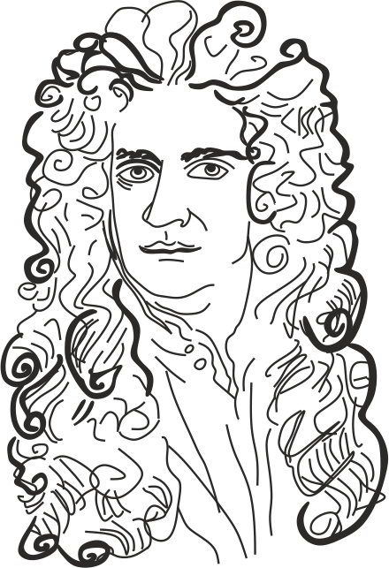

***Fig 1.0*** *Robert Hooke in 1665*

**Sample question – 02**

**Marian Girls/ mid –term Examination 2004**

* State the contribution of the following scientists in the study of Cell biology:

1. Robert Hooke
2. M.J. Schleiden and Theodor Schwann



**DISCOVERY OF THE CELL**

**Robert Hooke’s work**

The term cell was first discovered by the **Robert Hooke** in 1665 *(Fig 1.0*an English scientist, He investigated the thin slice of a cork (bark of a tree) under optical microscope. Hooke observed that, Cork was composed of boxes like compartments which were termed as cells; Although **Robert** **Hooke’s** microscope failed to show the internal parts but succeeded to show only the outer cell wall.

**What is the importance of studying cytology?**

The following are the significances of cell biology:

1. It helps us to understand on the biological structure and chemical composition of the cell.
2. It helps to understand the detailed structure and functions of different cells.
3. It helps to realize the role of cells in metabolic processes such as respiration.
4. It helps to understand the basis of genetics, the location, structure, chemistry and role of nucleic acid (DNA and RNA).
5. It is important in medical field, cytopathology since its knowledge is useful in diagnosis and treatment of diseases such as cancer.

**Sample question – 03**

**Tai question**

* **Explain the importance of studying cytology**



**1.2 THE CELL THEORY**

The ideas that cell is a basic structural and functional unit of life is known as ***cell theory*** or ***cell doctrine***. The cell theory was formulated by two scientists, *M. J. Schleiden*, a Belgian botanist in 1838 and *Theodor* *Schwann*, a German zoologist in 1839.

***What are the main ideas of the cell theory?***

The cell theory comprises of the following *four (4)* main ideas:

1. All living organisms are made up of one or more cells.
2. All new cells arise from the pre-existing cells by cell division.
3. Cells contain genetic materials which carry the genetic information from one generation to another.
4. Cells are the basic fundamental units of life, as all life processes and metabolic reactions are controlled by cells such as respiration. For this reason cells are referred to as the *structural and functional unit of life.*

**Sample question – 04**

**Style 1: Jecas 2011**

* Outline the main Ideas of the cell theory/ Doctrine



**Style 2: Tahossa/ Dar es Salaam – 2014**

* A cell is a basic unit of the life. substantiate

**Hint:**

Explain the idea number 4



**The added Ideas on the Modern cell theory:**

However, in the modern version of the cell theory, the following were the added ideas:

1. Energy flow occurs within cells in which all metabolic processes of life occur.
2. All cells have the same basic chemical composition, structures and functions complement to each other.
3. New cells are originated from pre – existing cells by cell division such as mitosis.

**Sample question -05**

**Mtwara and Lindi Mock – 2021**

1. Which Ideas of the cell theory were added in the modern version of the cell theory? Mention three (3) of them.
2. Draw typical bacterial and Euglenal cells and show differences between two cells.



**What are the weaknesses of the cell theory?**

Due to increased understanding on cell biology, the concept of the cell theory has been challenged based on the modern knowledge of *virology,* *blood cells* and *origin of the life*, the following are the challenges of the modern cell theory:

1. The theory does not account for viruses which can exist as cells, although they have no specific cellular structures such as mitochondria, Golgi apparatus and endoplasmic reticulum.
2. The theory does not account on the origin of the first cell from which the pre-existing cells originated by cell division.
3. The theory does not account, why some cells such as human red blood cells and sieve tube cells in angiosperms have no genetic materials or nucleus at maturity, but they are called cells.
4. The theory does not account for viruses, which only start its functioning when invade the host cells such as bacteria and animals.

**Sample question – 06**

**Style 1: Tabora boys sec school pre syndicate - 2021**

1. Briefly explain the challenges of the cell doctrine.
2. Describe the specificity of the enzyme based on the Key and Lock model.

**Style 2: Kinondoni Mock – 2013**

Ideas on cell theory is that:

* All living organisms are made of cells.
* All new cells arise from pre – existing cells.
* All metabolic processes take place within cells.

From biological point of view criticize these ideas.



**1.3 TYPES OF CELLS**

Based on the presence or absence of true nucleus, cells can be divided into **two** main types, namely **prokaryotic cells** and **eukaryotic cell**;Prokaryotic cells lack nucleus while eukaryotic cells have true nucleus.

**A. Prokaryotic cells**

The word *“Prokaryotic”* is derived from two Greek words *“Pro”* which means false and *“karyon”* which means nucleus. From this implication, Prokaryotic cells refer to those cells which lack true nucleus. That is to say, Prokaryotic cells are not enclosed by the nuclear membranes.i.e, materials are freely suspended in the cytoplasm. The common examples are bacteria and blue green algae, which are referred to as prokaryotes.

**What are the main characteristics of prokaryotic cells?**

Prokaryotic cells have the following general characteristics:

1. They are very small in size with average diameter of 1 – 5 µm.
2. They have few membrane bounded organelles, that is. They lack many membrane bound organelles such as mitochondria and Golgi apparatus.
3. They have circular and naked DNA, that is, the DNA is not associated with histone protein coat to form chromosome.
4. They have fewer and smaller ribosomes, 70’s.
5. The cell membrane folded into mesosomes for respiration.
6. They have flagella which lack microtubules of a “9 + 2” arrangement pattern.
7. They have cell wall made up of a carbohydrate - protein complex called murein or peptidoglycan.
8. They undergo nuclear division by mitosis only.
9. They reproduce asexually by binary fission.
10. Some have ability to fix nitrogen from the atmosphere such as azotobacter.

**Structure of a prokaryotic cell (*Fig 1.1*):**

A typical prokaryotic cell is made up of the following chemical components:

1. **Capsule**

**Capsule** is a polysaccharide layer surrounding the cell wall of some bacteria. Those bacteria with capsule are known as **capsulated bacteria**, which are extremely virulent and those without capsule are called **non-capsulated bacteria**.

**Roles of capsule**

* It protects a bacterium from drying out *(desiccation).*
* It adds protection to the bacterium against mechanical injury such as very high temperature.
* It helps in attachment on the surface, i.e. ***Streptococcus*** that cause dental carriers attach on teeth surface by its capsule.
* It prevents the bacterium from being engulfed *(phagocytosis)* by white blood cells.

1. **Cell wall**

**Cell wall** is a peptidoglycan or murein layer surrounding the bacteria. Those bacteria with thick layer of peptidoglycans are called **Gram positive** and those with thin layer of peptidoglycans are called **Gram negative.**

* It prevents bacterium against mechanical injury.
* It provides the cell shape.
* It serves as anchorage point for attachment of cilia in some bacterium.
* It acts as virulent factor, which is the ability to cause a disease.

1. **Cell membrane**

It is a double layer of phospholipids associated with proteins beneath the cell wall.

**Roles of cell membrane**

* It protects the inner contents of the cell *(intracellular materials).*
* It regulates the movement of materials into or out of the cell.
* It is folded into ***mesosomes*** which act as a site for respiration.
* In some bacteria such as azotobacter, it is folded into ***nitrogen fixing membrane*** for fixation of nitrogen gas from the atmosphere.

1. **Cilia**

These are shorter, thinner and straighter hair like structures projecting through the cell wall.

**Roles of cilia**

* They are used for attachment of bacterial cell.
* They act as specific receptors for bacteriophage.
* They involve in bacterial conjugation in which the bacterial cells exchange the genetic materials through plasmids.

1. **Flagella**

These are long, hollow and cylindrical structures outgrowing from the surface membrane. They are made up of microtubules “9 + 0” arrangement pattern.

**Role of flagella**

* They usual act as locomotive structures.

1. **Circular and naked DNA**

It is a genetic material in the cytoplasm of the bacteria, the bacterium DNA is not enclosed in a nuclear membrane, as the result the nuclear materials are freely suspended in the cytoplasm.

**Role of circular and naked DNA**

* It stores the genetic information for bacteria.

1. ***Plasmids***

These are small circular genetic materials with the capability of self-replication.

**Role of plasmids**

* They offer resistance to antibiotics. For example, in some bacteria the genes usual produce *penicillinase* *enzyme* which breakdown the antibiotic drug penicillin and thus preventing their cell wall from digestion.
* Some carry genes which cause disease.

1. **Ribosomes**

These are small structures in the cytoplasm of prokaryotic cells; usual prokaryotic cells contain 70 sedimentation coefficient ribosome.

**Role of ribosome**

* They play a crucial role in protein synthesis within the bacterial cell.



***Did you know?***

***“All of the bacteria in our body collectively weigh about 4 pounds“***

1. 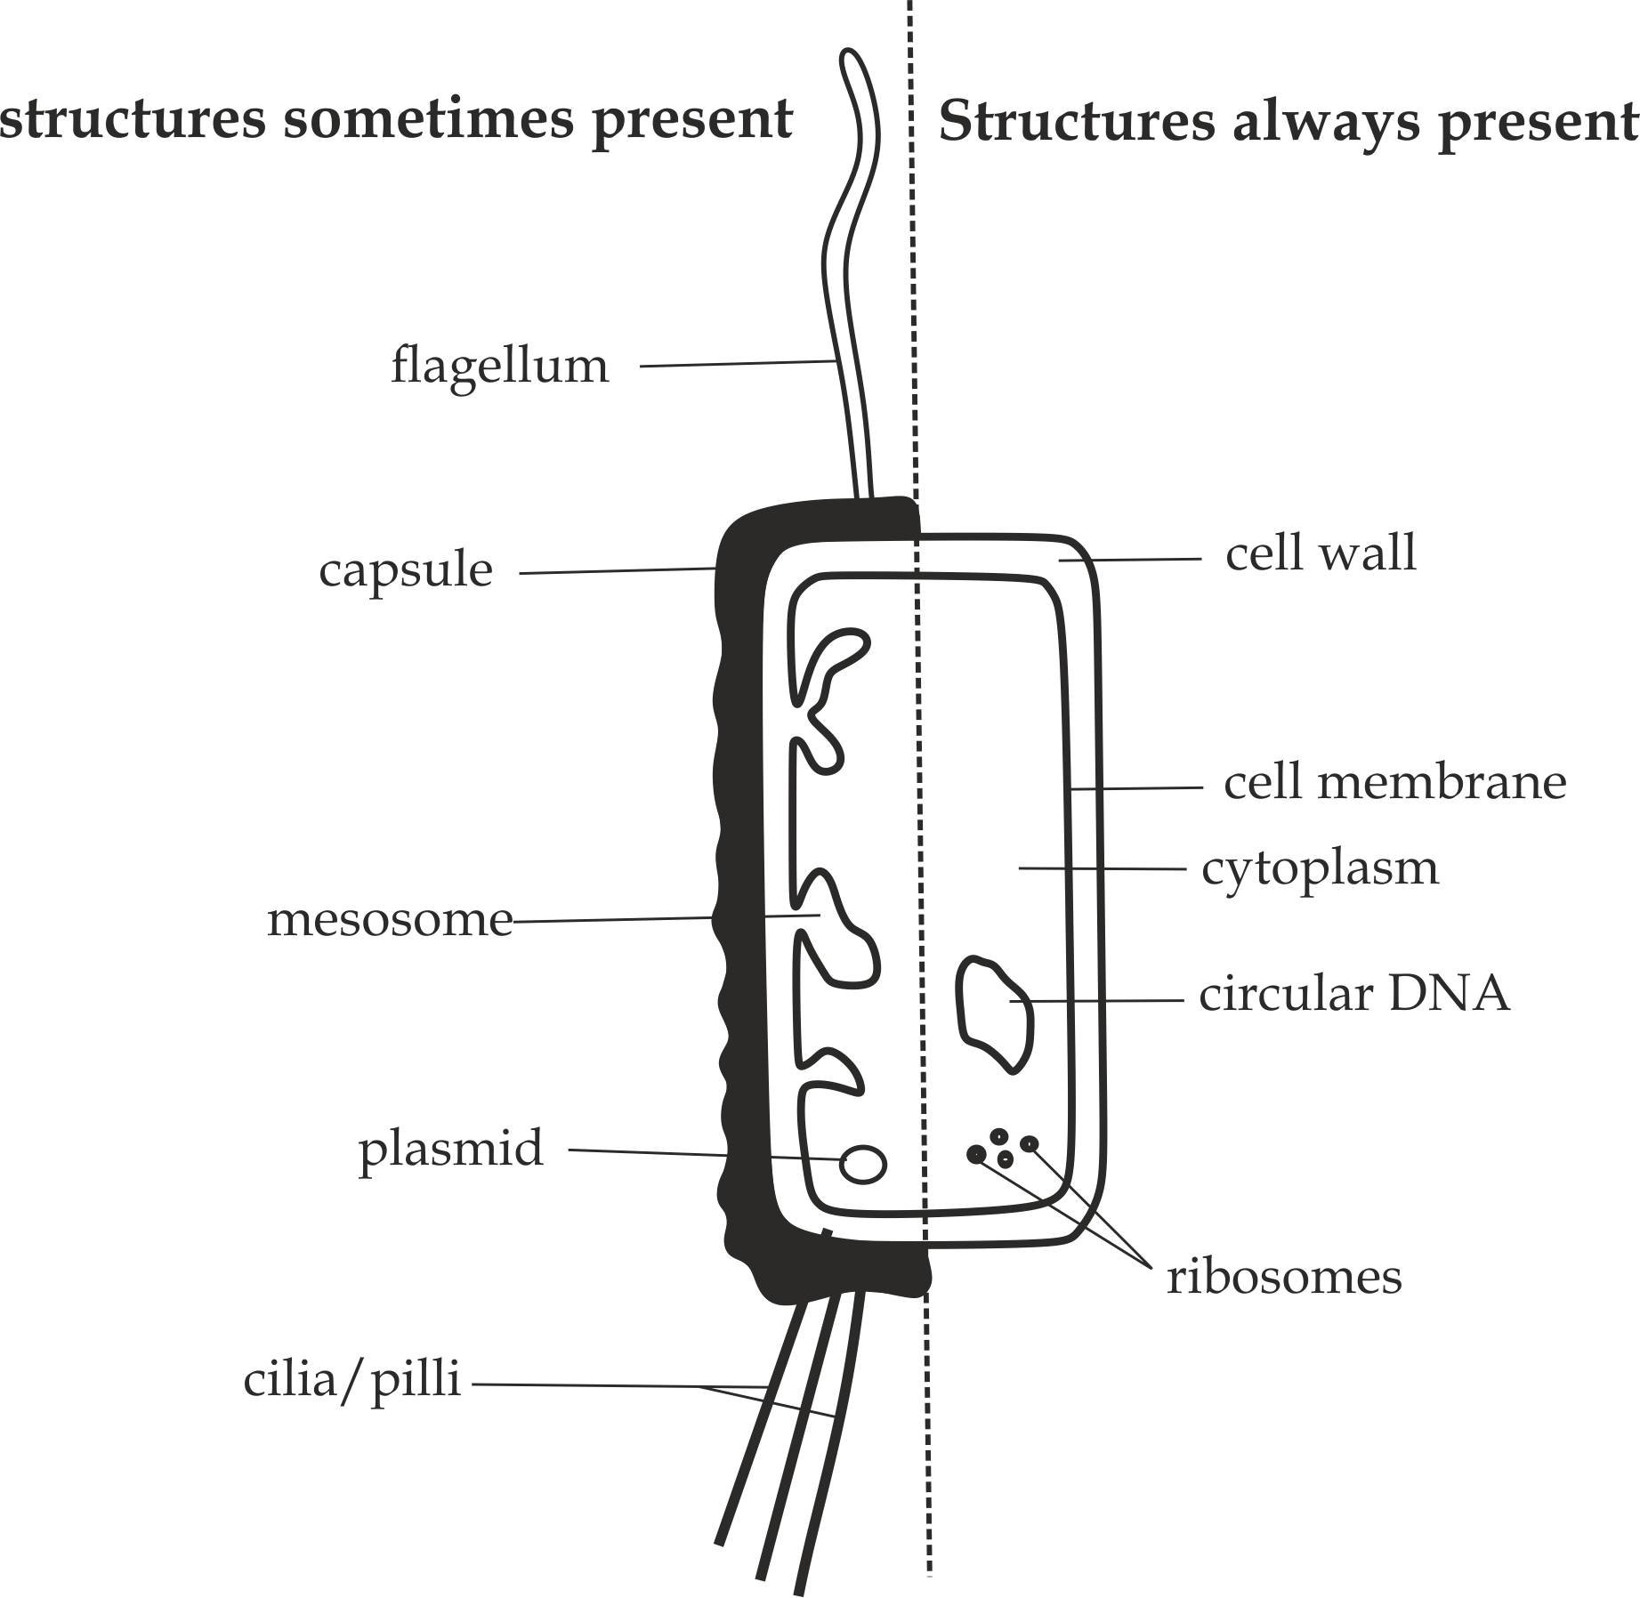

***Fig 1.1*** *Structure of a typical prokaryotic cell*

**Sample question – 07**

**Style 1: Necta 2011/ Biology 1**

* With the help of a well labelled diagram of a rod shaped bacterium, describe the structure of a prokaryotic cell.

**Style 2: Lake Zone Mock 2021/ Biology 1**

* Clearly draw a well labelled diagram of bacterium showing only, structures always present and structures responsible for:

1. Locomotion
2. Attachment
3. Protection
4. Pigmentation
5. Respiration



**B. Eukaryotic cells**

The word *“eukaryotic”* is derived from two Greek words *“Eu”* which means true and *“karyon”* which means nucleus. From this implication, Eukaryotic cells refer to those cells which have true nucleus. That is to say, Eukaryotic cells are usual enclosed by the nuclear membranes.i.e, materials are not freely suspended in the cytoplasm. The common examples are animal, plant, protoctista and fungal cells, which are referred to as eukaryotes.

**What are the main characteristics of prokaryotic cells?**

Prokaryotic cells have the following general characteristics:

1. They are very large in size with average diameter of 10 – 100µm.
2. They have many membrane bounded organelles such as mitochondria and Golgi apparatus.
3. They have larger helical DNA, that is, the DNA is usual associated with histone protein coat to form chromosome.
4. They have many and larger ribosomes, 80’s.
5. They have mitochondria necessary for respiration.
6. They have flagella which have microtubules of a “9 + 2” arrangement pattern.
7. Cell wall if present, it is made up of cellulose in plant cells and chitin in fungal cells.
8. They undergo nuclear division by either mitosis or meiosis.
9. They reproduce sexually,i.e.They involve meiosis during gamete formation
10. They have no ability to fix nitrogen from the atmosphere.

**Remember:**

In this **chapter 1**, only animal cell and plant cell should be discussed under electron microscope,

The rest cells will be discussed in classification.



**Structure of eukaryotic cells:**

1. **Structure of animal cell**

Animal cells are eukaryotic cells with a membrane bounded nucleus. Unlike the eukaryotic cells of plants, animals do not have cell wall and larger cell vacuoles. Animal cell comprises of different cell organelles and structure which perform specific functions necessary for the cell. Animal cells contain cell membrane, cytoplasm, nucleus, mitochondria, Golgi apparatus, endoplasmic reticulum, cytoskeletal structures, cilia, flagella, microvilli, lysosomes, peroxisomes, centrioles, ribosomes and cell inclusions as shown in *Fig 1.2*.

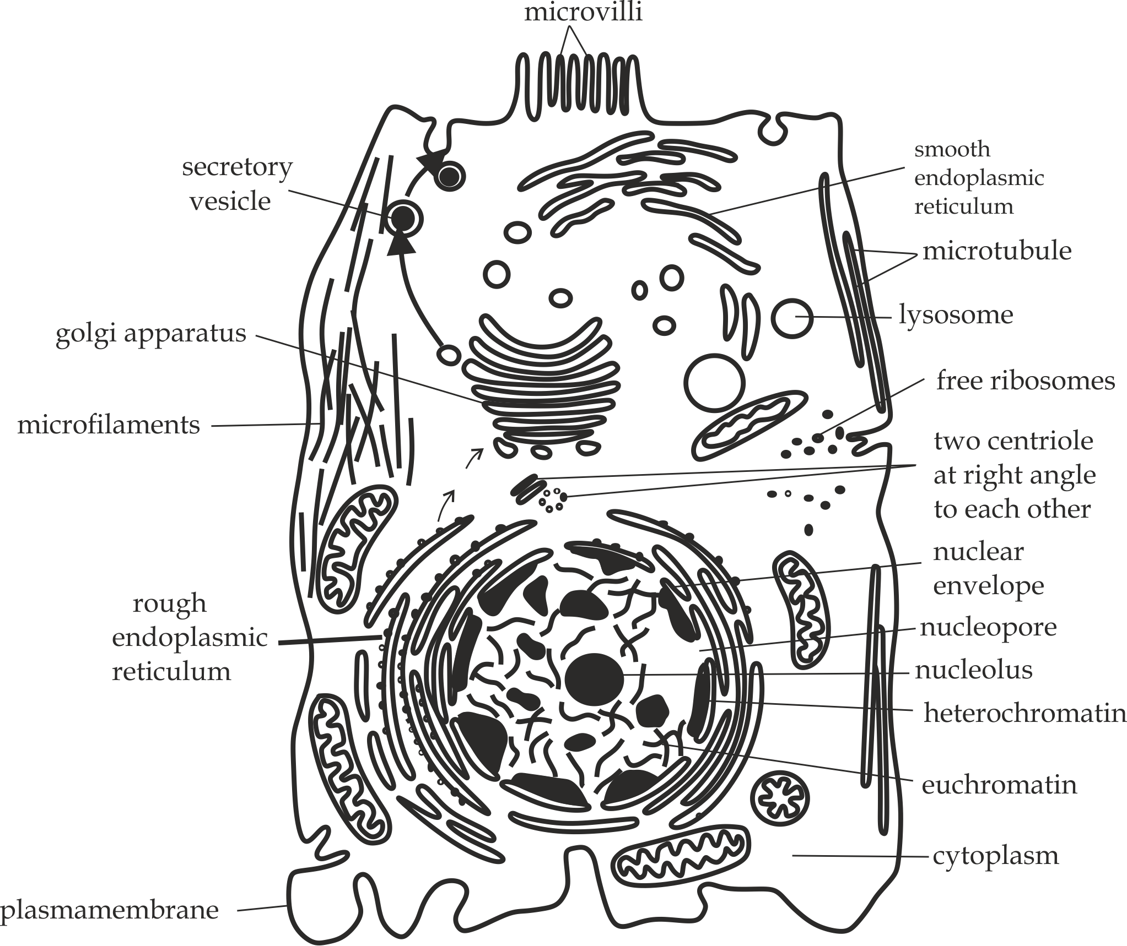

***Fig 1.2*** *Generalized structure of animal cell under electron microscope*

1. **Structure of plant cell (*Figure 1.3*)**

Plant cells are eukaryotic cells with the structure similar to that of animal cells, except that, plant cells have the following distinctive structures whereas animal cells do not have; ***firstly***, the plant cells have an outer layer surrounding the cells, called cell wall. It is composed of cellulose which provides protection, structural support and mechanical strength to the cell.

***Secondly***, the plant cells have plastids such as chloroplast capable of performing photosynthesis, and ***Lastly***, The plant cells have larger and permanent central vacuoles which are responsible for the storage of nutrients, metabolic wastes and also maintaining the turgidity of the cell.

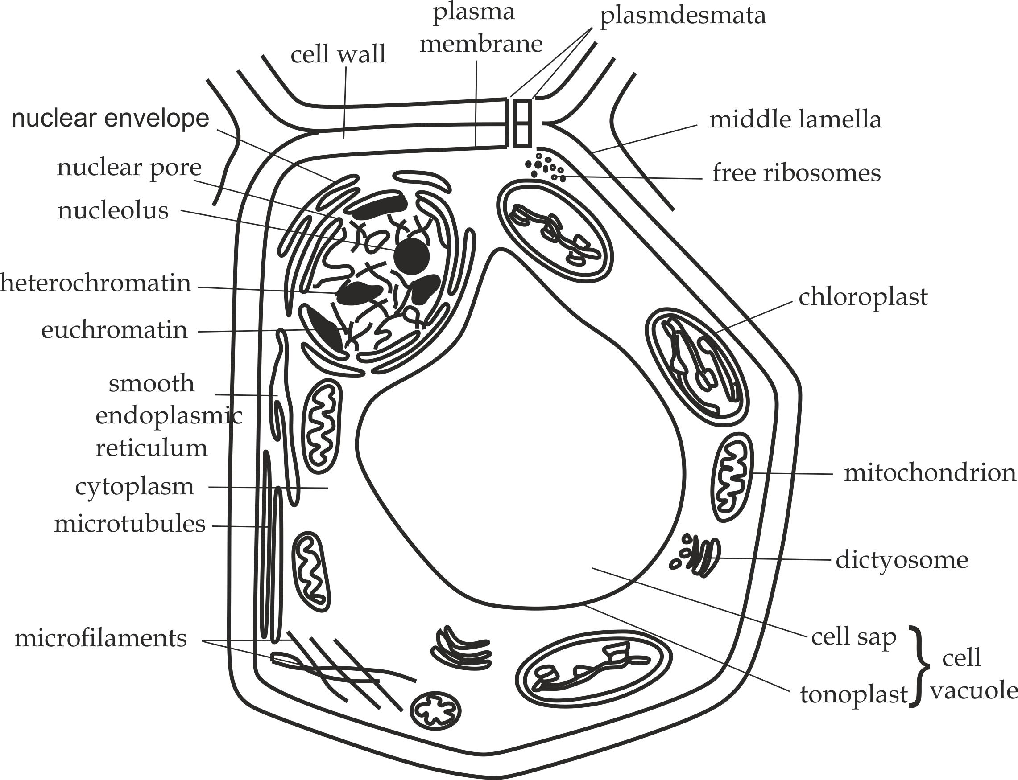

***Fig 1.3*** *Generalized structure of plant cell under electron microscope*

**Table 1.0 Differences between animal cell and plant cell:**

|  |  |
| --- | --- |
| **Animal cell** | **Plant cell** |
| It is irregular in shape. | It is regular in shape. |
| It has no cell wall. | It has a cell wall. |
| It has microvilli. | It has no microvilli. |
| Centrioles is present. | Centrioles is absent. |
| Nucleus is centrally located. | Nucleus is peripheral located. |
| Plastids are present. | Plastids are absent. |
| It has small cell vacuoles. | It has large cell vacuoles. |

**Similarities between animal cell and plant cell**

Animal cell and plant cell are both eukaryotic cells with the following similarities in terms of structure and characteristics:

* Both are larger in size.
* Both have many cell organelles.
* Both have helical DNA covered with histone protein.
* Both have many mitochondria for respiration.
* Both have specialized cilia and flagella with *“9 + 2”* microtubules arrangement pattern.
* Both undergo meiosis and mitosis cell division.

**Sample question – 08**

**Style 1: Necta 2005/ Biology 1**

1. Define a cell.
2. State **four** structural differences between animal cell and plant cell.

**Style 2: Kaizirege and Kemebos sec school 2019**

1. Draw an animal cell as seen under electron microscope and label the following parts only:
2. Microtubules
3. Cell membrane
4. Lysosome
5. Golgi apparatus
6. Microvilli

**Style 3: Jecas 2006/ Biology 1**

1. Draw a large diagram of a typical animal cell as seen under the electron microscope and label it fully.
2. What structures/ features of the animal cell revealed under electron are not visible under light microscope?
3. What roles are played by the following organelles:
4. Lysosomes
5. Vacuoles
6. Peroxisomes
7. centrioles

**Style 4: Mazinde Juu – pre Mock Exam 2002**

* Draw and label a structure of a typical plant as it is seeing under the electron microscope.



***Bonus conceptual questions:***

**Style 1: Morogoro Mock 2020**

* Draw a diagram of animal cell as seen under electron microscope and indicate the letter below the organelles responsible for the following:

1. Synthesis of steroids.
2. Formation of lysosomes.
3. Breakdown of red blood cell in spleen.
4. Movement of materials / *molecules* inside and outside of the cell.
5. Control synthesis of ribosomes.

**Hints:**

1. SER
2. Golgi apparatus
3. Lysosome
4. Cell membrane
5. Nucleus

**Style 2: Kibaha Terminal Exam 2010**

* Draw a diagram of a plant cell, indicate using letters below the cellular structures concerned with:

1. Formation of lysosomes.
2. Responsible for β – oxidation of fatty acids.
3. Manufacture of proteins.
4. It gives rigidity to the cell.
5. Photosynthesis.
6. Responsible for colourin*g* formation of leaves.
7. Control cell divison.
8. Connecting cytoplasm of adjacent cells.

**Hints**: Pleas would you try this!



**Table 1.2 Differences between Prokaryotic cells and eukaryotic cells:**

**Sample question – 09**

**Necta 2015 / Biology 1**

1. Differentiate between eukaryotic and prokaryotic cells basing on the following criteria:
2. Cell division
3. Genetic material
4. Cell wall
5. Flagella
6. Respiration
7. Photosynthesis
8. Nitrogen fixation

Tabulate your answer as shown below:

|  |  |  |
| --- | --- | --- |
| **Criteria** | **Prokaryotic cells** | **Eukaryotic cells** |
|  |  |  |

1. What is cell differentiation?



|  |  |
| --- | --- |
| **Prokaryotic cells** | **Eukaryotic cells** |
| i. They are smaller in size. | i. They are larger in size. |
| ii. They have few cell organelles. | ii. They have many cell organelles. |
| iii. They have circular and naked DNA. | iii. They have helical DNA with histone protein. |
| iv. They have smaller ribosomes.i.e. 70’s | iv. They have larger ribosomes. i.e. 80’s. |
| v. They have flagella which lack“9 + 2” microtubules arrangement pattern. | v. They have flagella with “9 + 2” arrangement pattern. |
| vi. They have mesosomes for respiration. | vi. They have mitochondria for respiration. |
| vii. They have cell wall composed of murein. | vii. They have cell wall composed of cellulose or chitin |
| viii. They reproduce asexually by binary fission. | viii. They reproduce sexually. |
| ix. They undergo nuclear division by mitosis. | ix. They undergo nuclear division by mitosis and meiosis. |

***Bonus conceptual question:***

**Bwiru Boys /mid – term Exam 2018**

Outline five differences between bacterial cell and trypanosome cell.

**Hints:**

Remember that, bacterial cell is a prokaryotic cell whereby trypanosome is a eukaryotic cell (belong to the kingdom protoctista).



**1.4: CELL ORGANELLES**

**Cell organelles** are structures which perform specific functions inside a cell, That is, each kind of a cell organelle performs a specific function, and thus a cell is able to live and performs its function because of these organelles. Quite interestingly, without them the cell is dead and valueless to life.

**Types of cell organelles:**

The following **seventeen (17)** cell organelles are isolated within the cells so that structure and function can be investigated outside the organism, a process known as **cell fractionation.**

1. **WALLS**
2. CELL WALL
3. MICROVILLI

**SPHERICAL**

1. LYSOSOME
2. PEROXISOME
3. CELL VACUOLE
4. RIBOSOMES
5. CENTRIOLES
6. CELL INCLUSSIONS
7. CELL MEMBRANE
8. **SURFACE**
9. CYTOPLASM
10. **LARGEST**
11. THE NUCLEUS
12. MITOCHONDRION
13. PLASTIDS
14. **MEMBRANEOUS**
15. GOLGI APPARATUS
16. ENDOPLASMIC RETICULUM
17. CYTOSKELETAL STRUCTURES
18. CILIA AND FLAGELLA

**1. CELL WALL**

**Cell wall** is an outer non-living boundary of the plant cells, fungal cells and bacterial cells. The chemical composition of cell wall among these organisms differs. The plant cell wall is made up of *cellulose*, the fungal cell wall is made up of *chitin* and bacterial cell wall is made up of peptidoglycans called *murein*. In this organelle, only plant cell wall will be discussed.

**Structure of plant cell wall (*Figure 1.4*)**

In plant cells, the cell wall is complex in nature which is differentiated into the following chemical components:

1. Primary cell wall.
2. Secondary cell wall.
3. Middle lamella.
4. Plasmodesmata.

a**. Primary cell wall**

**Primary cell wall** is the first wall formed in a growing (immature) plants during cell division.

**Nature of primary cell wall**

The primary cell wall is composed of the following properties:

1. **Location**: It is located internal to the *middle lamella*, That is*,* it is deposited on both sides of the middle lamella.
2. **Size*:*** It is very thin, that is, it is made up of single layer of microfibrils.
3. **Cellulose:**It has very low cellulose components with hemicellulose and pectin.
4. **Strength**: It lacks strengthening materials, hence it is soft and extensible.
5. **Occurrence*:*** It is found in all plants such as monocots and dicots.

**Role of primary cell wall**

* It allows the expansion of plants during growth and development.

b**. Secondary cell wall**

**Secondary cell wall** is the second wall formed in a matured plants after the cell has expanded.

**Nature of secondary cell wall**

The secondary cell wall is composed of the following properties:

1. **Location**: It is located internal to the *primary wall,* That is*,* it is deposited on both sides of the primary cell wall.
2. **Size*:*** It is very thick, that is, it is made up of three layers of microfibrils.
3. **Cellulose:**It has very high cellulose components with hemicellulose and pectin.
4. **Strength**: It contains strengthening materials such as lignin, suberin and waxy cutin, hence it is hard and inextensible.i.e. Suberin and waxy cutin act as waterproofing on the stem and leaves to prevent excess water loss. Lignin anchors the fibres together in tree bark to provide greater strength.
5. **Occurrence*:*** It is found in matured plants especially in dicots.

**Role of secondary cell wall**:

* It provides mechanical strength and support to the plants, especially in dicots such as woody plants.

c**. Middle lamella**

**Middle lamella** is a thin layer of pectin materials such as calcium and magnesium pectate which join neighbouring primary cell wall in plant cells. When the plant cells divide, the Golgi apparatus collect at the equator of the spindle, known as plate, immediately after nuclear division, they then fuse together and their membranes to form the new membrane known as ***middle*** ***lamella***.

d**. Plasmodesmata**

**Plasmodesmata** are small apertures (pits) which allow the exchange of materials between adjacent plant cells.

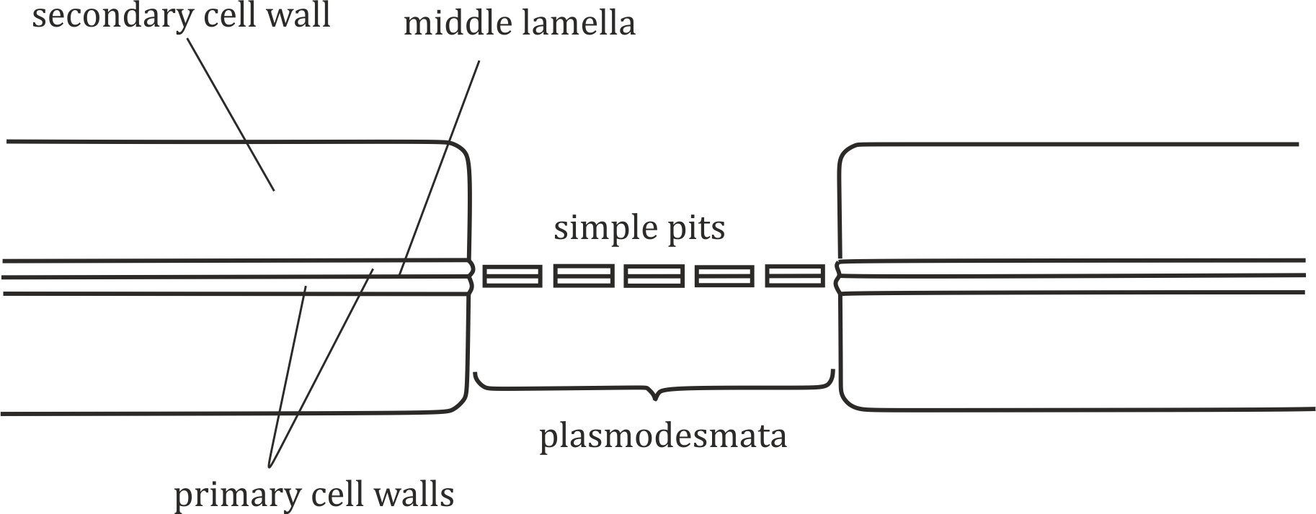

***Fig 1.4*** *Structure of cell wall*

**Sample question – 10**

**Lindi and Mtwara Mock 2022**

1. With the aid of diagram, describe the structure of cell wall of plant cell.
2. Explain the function of lignin and suberin in cell wall.
3. Name the structure which joins the neighbouring cell walls.



**Functions of cell wall**

Functions of plant the cell walls are depending on the position of the plant body, which includes the following:

1. **In leaves**

The cell wall of the leaves develop waxy cutin which prevents excess water loss by transpiration and entering of the pathogens.

1. **On stem**

The cell wall of the stem provides mechanical strength and support to the plants.

1. **In Xylem and phloem**

The cell walls in the xylem vessels, tracheid’s and phloem sieve tubes are much adapted for long distance translocation of materials.

1. **In roots**

The cell wall in the roots endodermis is suberized to form the casparian strip which act as a barrier which prevents the movement of water and toxins through the cell wall.

1. **In seeds**

Hemicelluloses in some seeds are modified as food reserves.

1. **In plant cell**

* It prevents cell from the osmotic bursting, thus maintain turgor pressure (cell *turgidity).*
* It provides strength and rigidity to the cell due to the presence of pectinmaterials.
* Itprovides *cell shape*.
* It protects the inner contents of the *cell*.



**Sample question – 11**

**Necta 2012 / Biology 1**

1. What advantages do cells have due to their small in size?
2. State the functions of the cell walls.
3. **CELL MEMBRANE**

**Cell membrane** is the outer living boundary which encloses the cytoplasm of the cells. The cell membrane separates the contents of the cell from the environment, it is also known as *plasmallema* or *plasma* *membrane*. In animal cells, plasma membrane is the outermost layer, where as in plant cells, it is located beneath the cell wall.

**Structure of the cell membrane**

There are two (2) main models suggested to describe the structure of the cell membrane, namely:

1. Danielli – Davson model in 1935.
2. Fluid mosaic model in 1972.

a**. Danielli – Davidson model (1935) (*Figure 1.5*)**

Danielli – Davidson model is the traditional model which described the structureof the cell membrane; According to this model, it *states* that:

“***The cell membrane is structurally composed of two continuous layers of proteins with phospholipid bilayer embedded in between****”*.

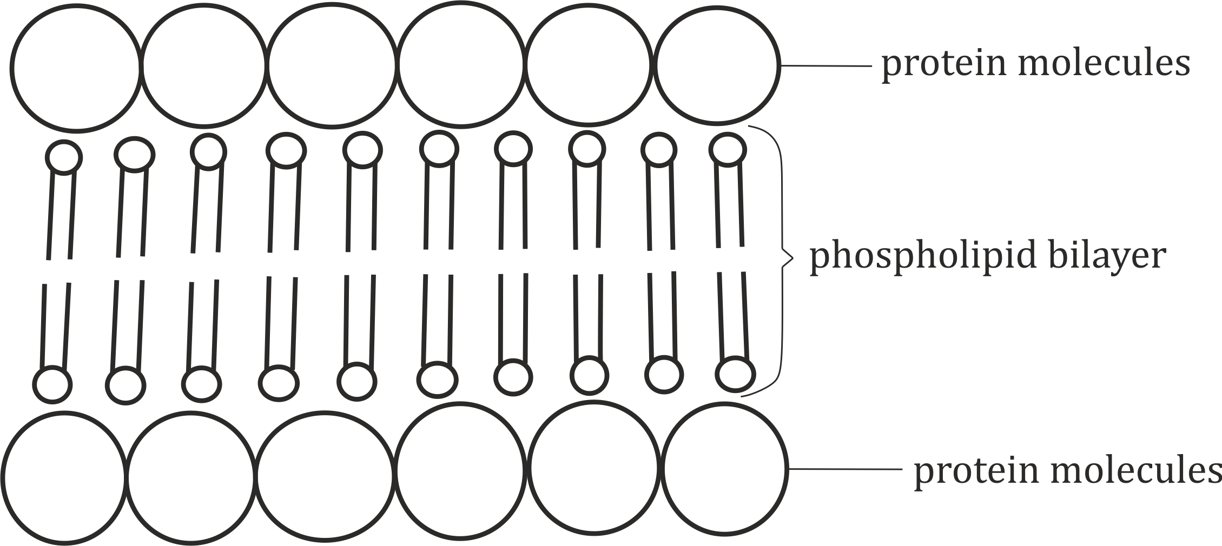

***Fig 1.5*** *Danielli – Davson model of cell membrane*

**Key concepts:**

* The model is also described as “**sandwich model”** of a cell surface membrane; because a phospholipid bilayer is sandwiched between two layers of protein.
* The phospholipid molecules have polar head *(hydrophilic)* or water loving part and non-polar tails *(hydrophobic) or* water hating parts.
* The model does not explain the presence of pores which allow the passage of materials into and from the cell.
* The model does not explain the presence of other vital chemical constituents such as *carbohydrates* and *cholesterol*.
* Moreover, the protein bilayers are said to be continuous, this makes the cell membrane to be static, and that cannot be subjected to the change.

**Strength of the model**

1. It is true that, cell membrane (plasmallema) consists of proteins and phospholipid bilayer.
2. It is true that, the phospholipid has polar head and non-polar tails*.*

**Weakness of the model**

1. It is not true that, the cell surface membrane is *static*, but rather dynamic in nature.
2. It does not recognize the presence of *pores* in the protein layer.
3. It does not indicate the presence of *carbohydrates* and *cholesterol* as other chemical constituents of the cell membrane.



**Sample question – 12**

**Msalato Girls High school/ Pre Mock Exam 2020**

1. With the aid of a well labelled diagram, describe the structure of a plasma membrane as proposed by Danielli – Davson model.
2. Explain any **four (4)** strength of the fluid mosaic model.

b**. Fluid mosaic model (1972) (Figure 1.6)**

Fluid mosaic model of the cell membrane was formulated by **J. Singer** and **Garth Nicholson** to modify the Danielli – Davidson model.

According to this model, it states that:

***“The cell membrane is composed of phospholipid bilayer with protein molecules float on it”***

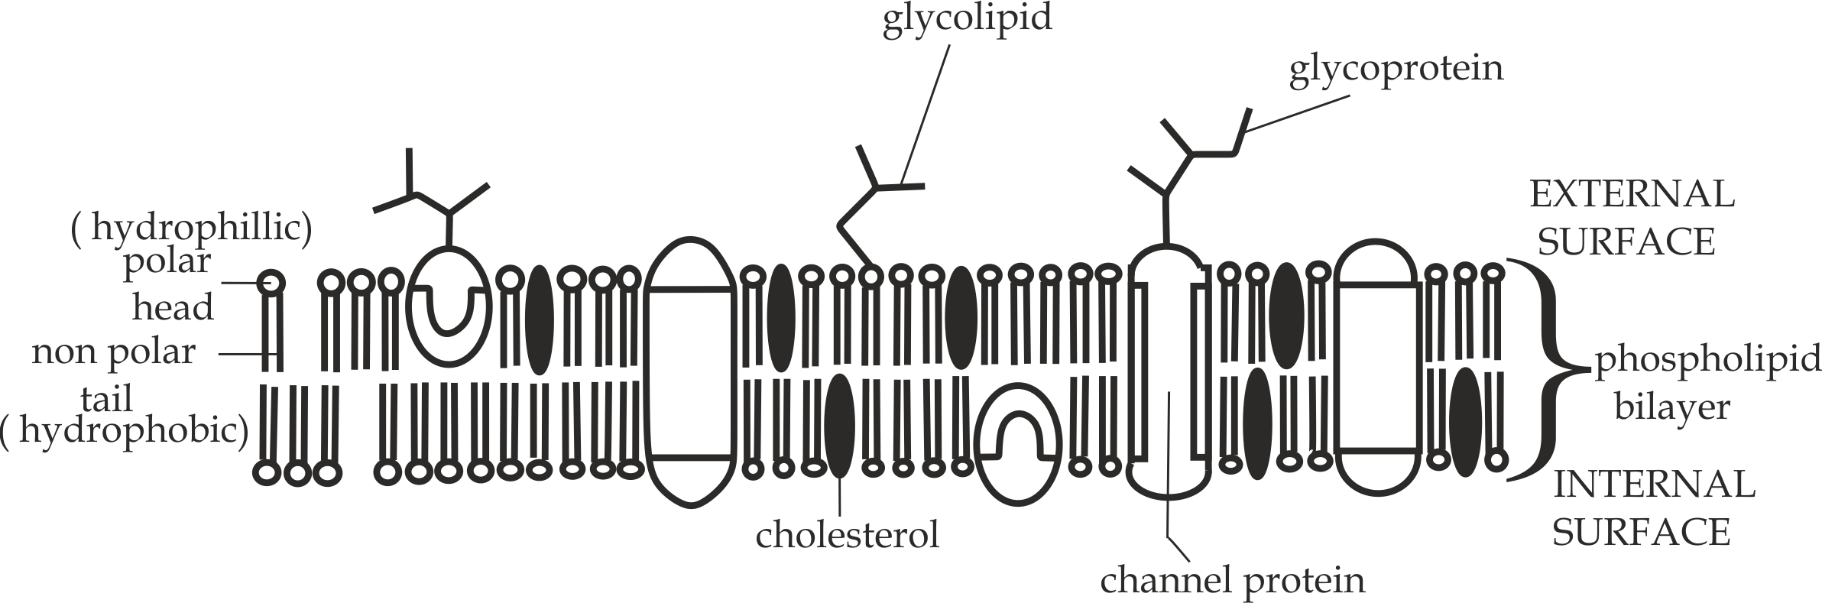

***Fig 1.6*** *Structure of a cell surface membrane as per fluid mosaic model*

***Key concepts:***

* The model is described as ***“Fluid”***, because it is thought that the phospholipid bilayer is capable of much movement and as ***“Mosaic”*** is due to arrangement of proteins in a phospholipid bilayer that is extrinsic, intrinsic and integral arrangement pattern.
* The membrane has pores which allow the passage of molecules into and from the cell.
* The membrane has carbohydrates branching from protein *(glycoprotein)* and from the phospholipid *(glycolipid).*
* The membrane also contains cholesterol which regulates fluidity and flexibility of the membrane by disturbing the phospholipids.
* Moreover, Due to constant motion, the membrane is not static but rather dynamic.

**Strength of the Model**

1. It is true that, the membrane is phospholipid bilayer.
2. It is true that, protein is present in the membrane.
3. It is true that, carbohydrates are present.
4. It is true that, cholesterol molecules are present.
5. It is true that, the membrane has pores which allow the passage of molecules into and from the cell.
6. It is true that, the membrane is *dynamic*.

**Weakness of the Model**

1. The model does not indicate the presence of electrolytes such as Na+ and Cl-.

**Sample question – 13**

**Style 1: Tusiime sec school 2014**

1. Draw a well labelled diagram of a cell membrane structure as investigated by Singer and Garth Nicholson in their fluid mosaic model.

**Style 2: Kilimanjaro Mock 2020**

1. In living cell, an Organelle controls exchange of materials which have been described using different models is called cell membrane. By using well known and accepted model, describe its structure.
2. Explain any four strength of the above accepted model.
3. Name the chemical constituents of membranes and enumerate the role of each.



**Style 3: Necta 2003 / Biology 1**

**Figure 1** below is a diagram of the “*fluid mosaic* *model* “of the cell membrane structure. Study the figure carefully and then answer the question which follow:

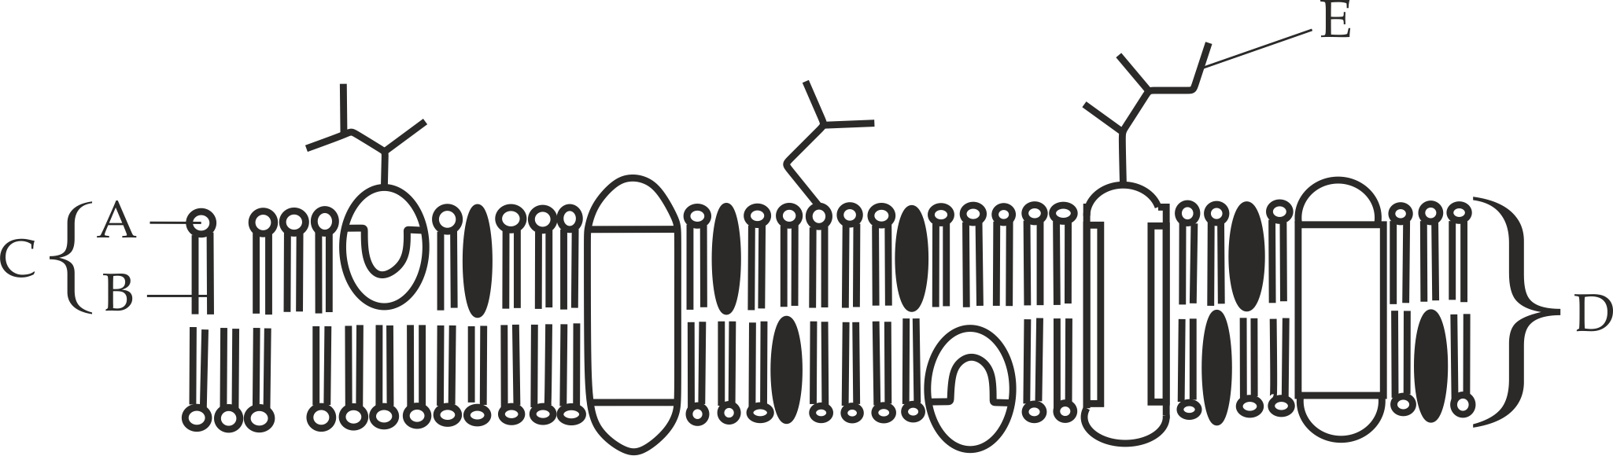

**Figure 1**

1. Name the structure represented by the labels A, B, C and D.
2. Name the biochemical substance formed when E and F combine.
3. What roles does structure F play in the function of a membrane?



**Composition of a cell membrane**

Cell surface membrane is chemically composed of the following chemical components:

1. Phospholipid
2. Cholesterol
3. Proteins
4. Carbohydrates
5. **Phospholipid**

**Phospholipid** is a compound lipid which is made up of two fatty acids, a phosphate group and glycerol molecule. The phosphate group acts as a polar head which dissolves in water or water loving (**hydrophilic**) and the fatty acids act as non-polar tails which do not dissolve in water or water hating (hydrophobic). The polar phosphate heads would be on the outside of the layer because they can interact with water and the non-polar fatty acid tailswhich will be away from the water on the inside of bilayer; Such a molecule is described as **amphipathic**, this property of phospholipids is important in determine the structure of the cell surface membrane as shown in *Figure 1.7.*

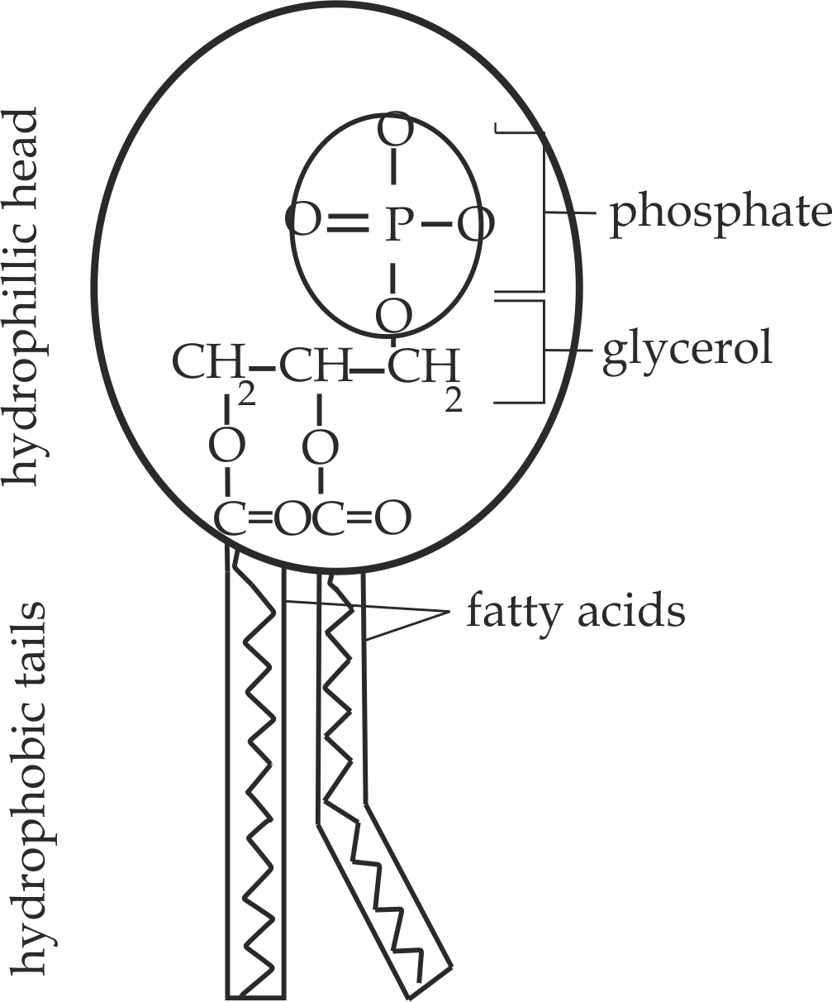

***Fig 1.7*** *Structure of a phospholipid*

**Roles of phospholipid**

1. They provide main structural framework of the cell membrane, this referred to as phospholipid bilayer.
2. They allow the passage of non-polar molecules such as gases and lipid soluble molecules such as fatty acid and glycerol by diffusion.
3. They give the membrane **fluidity** and **flexibility**; this is because phospholipid molecules normally are capable of much movement.

b**. Cholesterol**

**Cholesterol** is the most abundant steroid which is derived from the hydrolysis of simple and compound lipid *(The chemical structure of* *cholesterol and its side effects will be discussed in* ***chapter 2****).*

**Role of cholesterol**

1. It regulates the *fluidity* and *flexibility* of the membrane by disturbing the close packing of the phospholipids, For example, it makes the membrane less fluid at higher temperature to prevent evaporation but more fluid at lower temperature to prevent freezing.
2. **Proteins**

**Proteins** consists of about 70% of the total chemical components of the cell membrane, normally the roles of proteins are depending on the type of protein in the cell membrane, which includes the following:

1. **Channel proteins**

These are proteins which allow the passage of molecules or ions by facilitated diffusion.

1. **Carrier proteins**

These are proteins which allow the passage of molecules or ions by the active transport.

1. **Receptor proteins**

These are proteins which bind to the specific signal molecules such as hormones and neurotransmitters that trigger cellular response.

1. **Enzyme proteins**

These are proteins that carry out the metabolic reactions such as in electron transport chain of the respiration.

1. **Junction proteins**

These are proteins that connect together two adjacent cells to provide structural and supportive role, such as peripheral proteins (extrinsic proteins) in the cell membrane of the muscle tissues which aid in contraction.

1. **Carbohydrates**

**Carbohydrates** are the third major component of plasma membrane; they are always found on the exterior surface of the cell and are either bound to proteins (forming glycoprotein) or to lipids (forming glycolipid).

**Role of glycoprotein and glycolipid**

1. They act as **cell recognition sites**, this recognition function is very important to cells, as it allows the immune system to differentiate between body cells (called self ”) and foreign cells (called non self”).

**Sample question – 14**

**Style 1: Tai question**

* Name the chemical constituents of membrane and enumerate the role of each.

**Style 2: Pre – Mock Mtwara and Lindi 2022**

How cholesterol controls fluidity of the cell under the following condition:

1. High temperature
2. Low temperature



**MODES OF TRANSPORT ACROSS THE MEMBRANE:**

The movement of materials in and out of cells is achieved by **three (3)** main ways; which include **active transport**, **passive transport** and **bulk transport*.***

1. **ACTIVE TRANSPORT**

**Active transport** is the movement of materials (molecules or ions) against the concentration gradient by using ATP energy as shown in *Fig 1.8*.

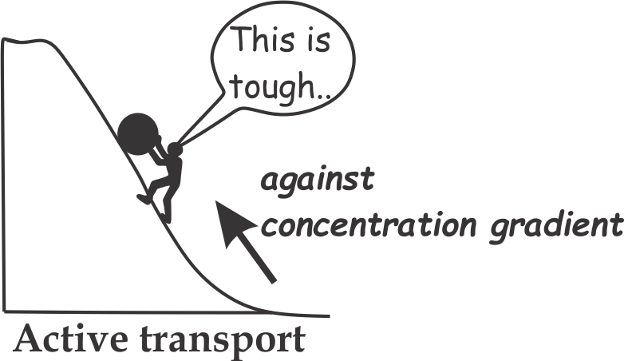

**Properties of active transport**

1. **Active transport** requires energy. The energy for active transport comes from respiration. Anything that inhibits the synthesis of ATP stops active transport. ***Cyanide***, for example, prevents ATP being synthesized and therefore inhibits active transport.
2. **Active transport** often moves molecules or ions against the concentration gradient that is from low concentration region to high concentration region.
3. **Active transport** involves the use of carrier proteins coupled with a source of energy (ATP).
4. **Active transport**is the one way system, so that substances are only moved in the direction required by the cell.
5. **Active transport** occurs rapidly, thus, it occurs in the body parts in which quickly and effective movement is required such as in the nerve cells during the conduction of the nerve impulse.

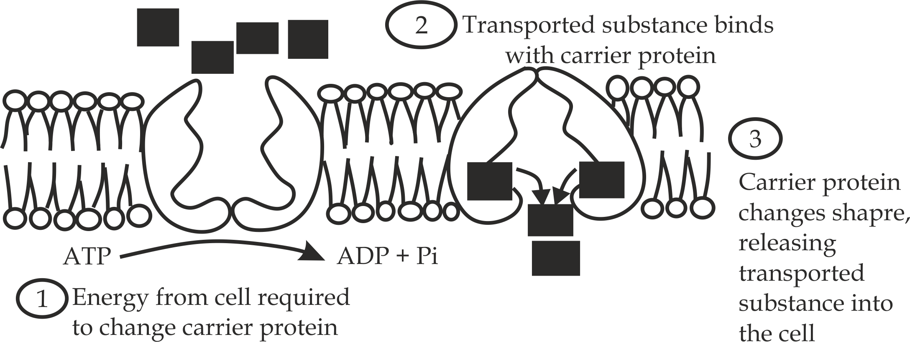

***Fig 1.8*** *Active transport*

**Examples of active transport include:**

* **Active transport** in the intestine for the absorption of the end products of digestion.
* **Active transport** in the nerve cells for the transportation of the nerve impulse, i.e***. Na – K pump***.
* **Active transport**in the kidney for the selective reabsorption of useful materials into the blood.
* **Active transport**in plant roots forreabsorption of minerals from the soil.

**Advantages of active transport**

1. It ensures that even if the soluble food molecules are in concentration lower than those already present in the blood, they will still flow into the blood.
2. It is more efficient and effective since it ensures that no any material is left.

**Sample question – 15**

**Necta 1998**

* Explain why it is important that, active transport is employed in the absorption of end product of digestion.



1. **PASSIVE TRANSPORT**

**Passive transport** is the movement of materials (molecules or ions) along the concentration gradient without the expenditure of ATP energy.

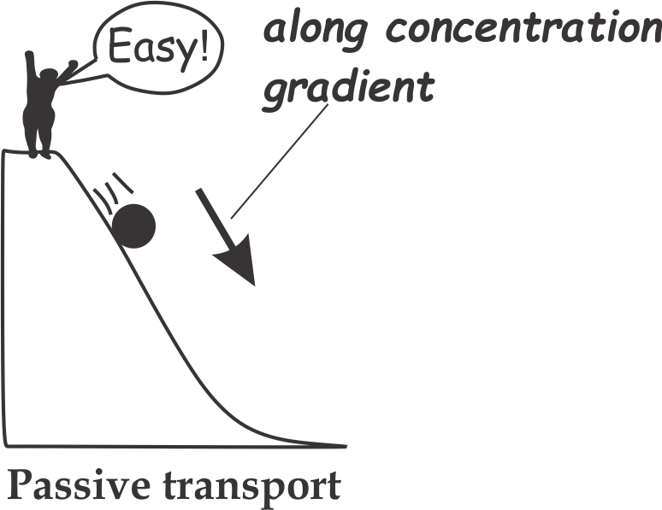

**Properties of passive transport**

1. **Passive transport** does not require energy for the transportation of molecules or ions.
2. **Passive transport** often moves molecules or ions along the concentration gradient that is from high concentration region to low concentration region.
3. **Passive transport**does not require transport protein except facilitated diffusion which only involves *channel protein.*
4. **Passive transport**is the two ways system, substances move in both directions across the membrane.
5. **Passive transport** occurs slowly, thus in the body parts which requires high rate of transportation such as alveolus of the lungs it must increase its surface area for maximum rate of diffusion.

**Types of passive transport**

Passive mode of transport is divided into ***three (3)*** main types, which includes; *simple diffusion*, *facilitated* *diffusion* and *osmosis*.

**a. Simple diffusion**

**Simple diffusion** is the movement of materials *(molecules only)* along the concentration gradient through the phospholipid bilayer of the cell surface membrane as shown in *Figure 1.9.*

**Examples of simple diffusion include:**

* **Simple diffusion** in the alveolus of the lungs for the transportation of respiratory gases such as oxygen gas and carbon dioxide gas.
* **Simple diffusion** in the intestine for the absorption of lipid soluble food such as fatty acids, glycerol and lipid soluble vitamins such as vitamin A, D, E, K.

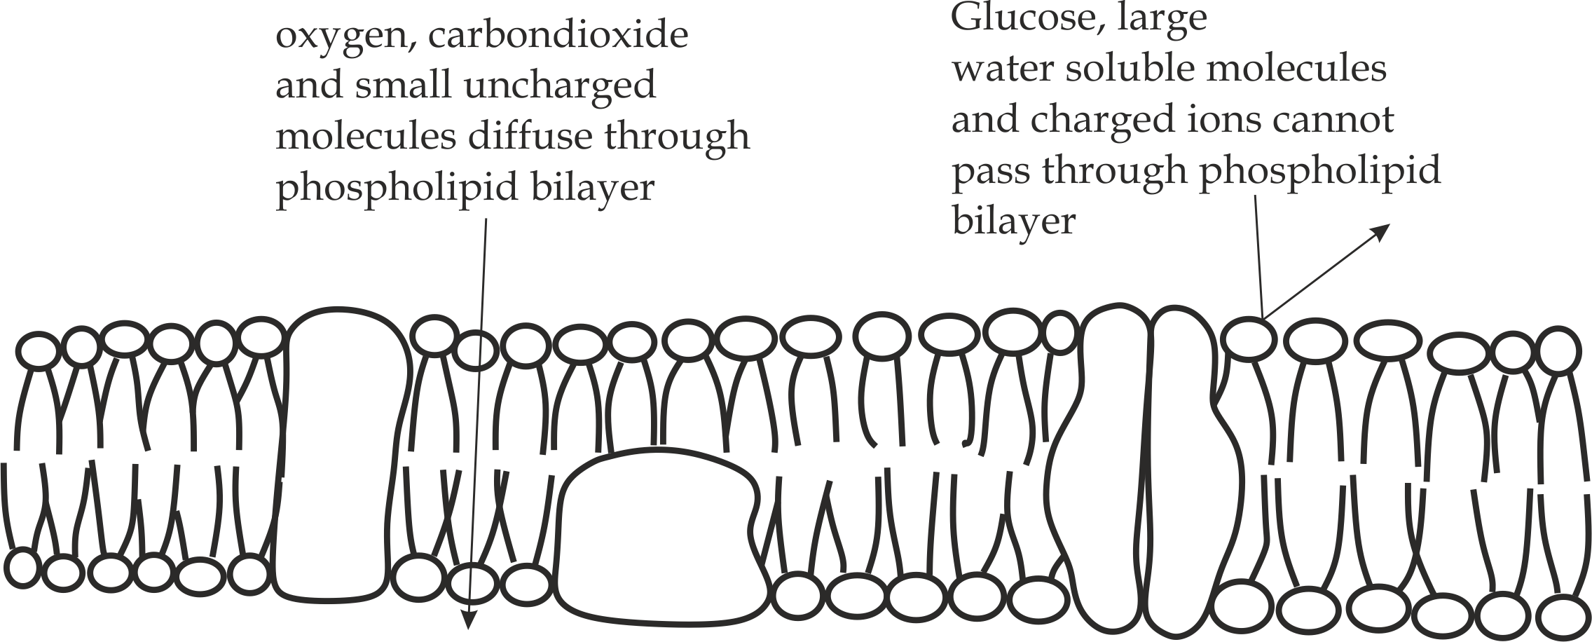

***Fig 1.9*** *Simple diffusion*

**Factors affecting the rate of diffusion**

The rate of diffusion across the cell membrane is affected by the following factors:

1. **Surface area to volume ratio**

The larger the surface area to volume ratio of the substance, the greater the rate of diffusion.

1. **Concentration gradient**

The greater the concentration gradient difference between two regions of a substance, the greater the rate of diffusion.

1. **The diffusion distance**

The shorter the distance between regions of different concentration, the greater the rate of diffusion.

1. **The size of diffusing molecules**

Smaller molecules diffuse faster than the larger molecules.

1. **The nature of diffusing molecules**

Fat soluble molecules diffuse faster than water soluble molecules.

The factors affecting the rate of diffusion across a membrane are summarized in **Fick’s Law:**

***″ the rate of diffusion is directly proportional to the concentration difference and surface area, and inversely proportional to the diffusion distance”***

Rate of diffusion **** *Surface area x concentration difference*

*Membrane thickness*

**Sample question – 16**

**Necta 2012/ Biology 1**

* Briefly explain **five (5)** factors affecting the rate of diffusion across the membrane.



1. **Faccilitated diffusion**

**Facillitated diffusion** is the passive movement of molecules or ions along the concentration gradient by using channel proteins.As with simple diffusion, the movement occurs down a concentration gradient and does not require metabolic energy as shown in *Fig 1.10*.

**Examples of facillitated diffusion include:**

1. **Faccilitated diffusion** in the small intestine which involves the absorption of polar molecules such as ions, *Na+* and *Cl-*  absorption of larger molecules such as glucose and aminoacids which can not pass by simple diffusion across the membrane.
2. **Facillitated diffusion** in theplacenta which facillitate the passage of ions, glucose, aminoacids and vitamins from the mother to the fetus for proper growth and development of the fetus during pregnacy.

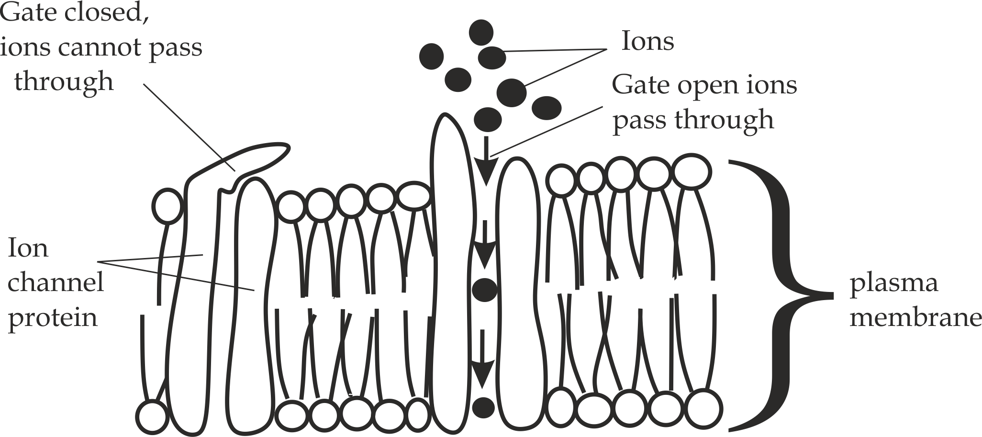

***Fig 1.10*** *Facilitated diffusion*

1. **Osmosis**

**Osmosis** is the movement of water molecules from the region of high water potential *(****less negative water* *potential)*** to the region of low water potential ( ***more negative water* *potential****)* through the partially *(semi)* permiable membrane as shown in *Figure 1.11*.

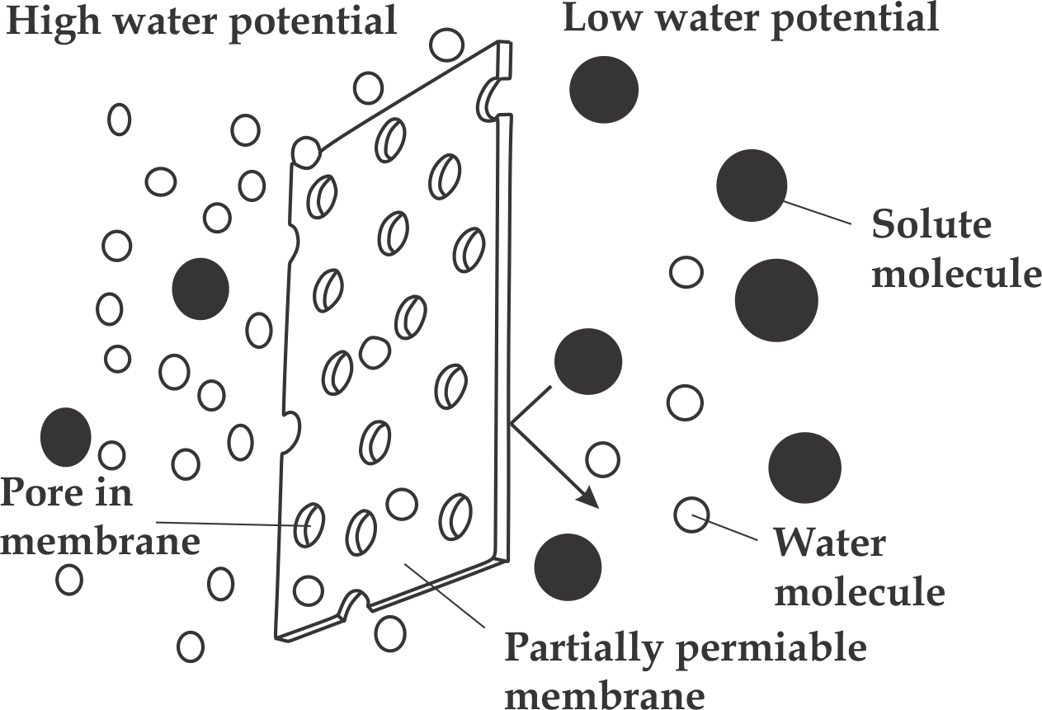

***Fig 1.11*** *Osmosis*

**The concept of water potential**

**Water potential** is the term given to the tendency of a sysytem to loose water by osmosis. A solution always has a  *negative* water potential due to the presence of solutes.Pure water has the highest water potential, which is given as a water potential of *zero*.

* The symbol used for the water potential in cells is **ψ***(Greek letter Psi).*
* The Si unit of water potential is customary to expressed in **Kpa.**

**Components of water potential**

Two important factors that determine the water potential of solution in and around the living cells are the presence of dissolved solutes (giving rise to a (**solute potential)** and mechanical pressure acting on water (**pressure** **potential*).***

1. **Solute potential**

**Solute potential** is a measure of water potential of the system in a dissolved solute molecules.Solute potential is always **negative**.Solute potential was previously reffered to as “**osmotic pressure***”* or “ **osmotic****potential***”*. If you go on adding solute, the water potential gets lower and lower,i.e more and more negative, this reducing the number of water molecules that can diffuse out of it *(remember water potential is the capacity of a system to loose water),*Solute potential is represented by the symbol of ψs.

1. **Pressure potential**

**Pressure potential** is the hydrostatic pressure exerts on water molecules by the cell wall. i.e, Pressure potential is always **positive**.The pressure potential was previously known as *“* **Turgor pressure***”* or “ **wall pressure***”*,Pressure potential is represented by the symbol of ψp.

**We can summarize the water potential (ψ) relations of a plant cell by this equation:**

**Water potential = solute potential + pressure potential**

(Usually negative) (Always negative) (Usually positive)



**Remember:**

At S.t.p ψp = 0

Thus, ψ = ψs + ψp (0); Therefore;

**ψ = ψs**

**Case 1: Dar – Mock 2018**

* The diagram below shows a plant cell immersed in a sucrose solution.

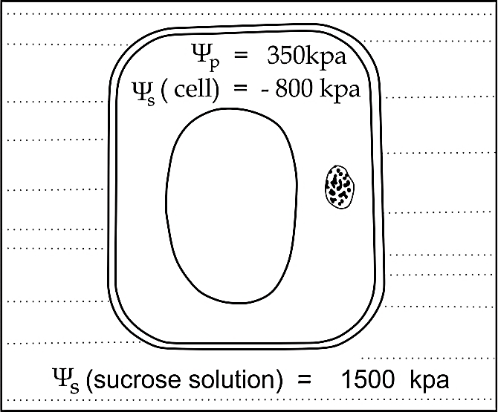

1. Calculate the water potential of the cell.
2. State whether water will move into or out of the cell. Explain your answer

**Answer:**

1. Water potential = solute potential + Pressure potential

ψ = ψs + ψp

ψ= - 800 Kpa + 350 Kpa = - 450 Kpa

1. Water will move outside of the cell to sucrose solution because the cell has higher water potential (**- 450 Kpa**) than the sucrose solution ( **- 1500Kpa**) and water normally moves from the region of high water potential to a region of low water potential by osmosis.

**Case 2: Possible question:**

* The diagram below shows the two adjacent plant cells **A** and **B.**The values of their pressure potential (ψp) and solute potential(ψs) are given in kPa.

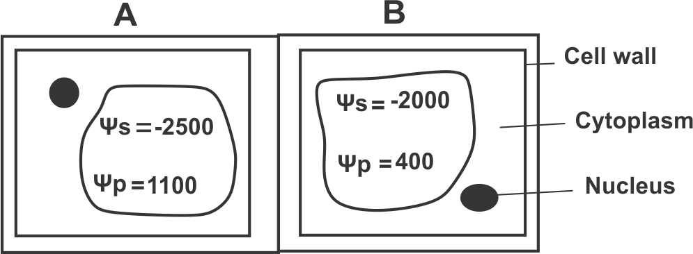

**Cell A Cell B**

1. In which direction will water molecules flow when the two cells are in contact with one another?
2. What will happen to the cytoplasm in both cells if plasmolysis occurs in both of them?

**Answer:**

1. To arrive at the answer to this question we have to calculate the water potential of each cell from the relationship ψ = ψs + ψp

For cell A: ψ = -2500 + 1100

Ψ = -1400kPa

For cell B: ψ = -2000 + 400

Ψ = -1600kPa

Therefore water will flow from **cell A** of high water potential( **-1400kpa)** to **cell B** which has low water potential **(-1600**).

1. When the cells are plasmolysed, water is lost from the cytoplasm and the vacuole.The protoplast(the living contents of the cell) surrounded by the cell walls will shrink and eventually get detached from the cell wall.

**Case 3:**

* Observe the **figure 2** below and answer the following questions:

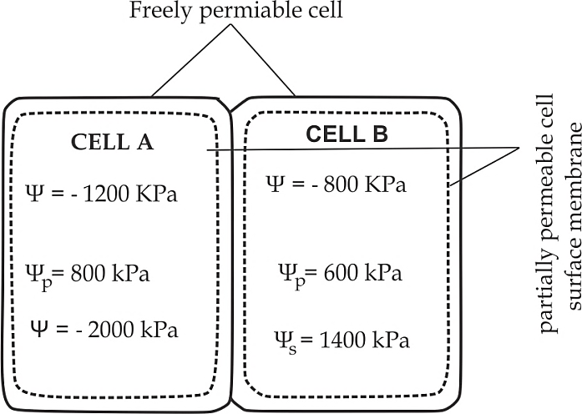

**Figure 2**

1. Which cell has the higher water potential?
2. In which direction will water move by osmosis?
3. Assuming that solute potential does not change significantly. What would be pressure potential at equilibrium in cell A and cell B?

Answer

1. Cell B
2. From Cell B to A
3. First, determine the water potential of **cell A** and **B** at equilibrium. This will be the average of the two.

Data given:

Ψ (water potential for cell A) = - 1200kpa

Ψ (water potential for cell B) = - 800 Kpa

Average = ψA + ψB

2

= (-1200 + -800) kpa

2

= -1000 kpa

Then; Pressure potentials (ψp) at equilibrium in cell A and B, will be as follows:

* Cell A at equilibrium: ψp = ψ - ψs

= -1000kpa - -2000kpa

= 1000 kpa

* Cell B at equilibrium : ψp = ψ - ψs

= - 1000 kpa - -800kpa

= 400 kpa

**Table 1.3 Differences between passive transport and active transport**:

|  |  |
| --- | --- |
| **Active transport** | **Passive transport** |
| i. It occurs against the concentration gradient of the membrane. | i. It occurs along the concentration gradient of the membrane. |
| ii. It requires the expenditure of energy during the passage of materials. | ii. It does not require the expenditure of energy. |
| iii. It is a rapid process. | iii. It is a slow process. |
| iv. It is more efficient. | iv. It is less efficient. |
| v. It occurs in only one direction, | v. It occurs in both directions. |

**Sample question – 17**

**Tahossa North Eastern Zone 2011**

* Differentiate between active transport and passive transport.



**Roles of osmosis in living organisms**

* It facilitates the movement of water from cell to cell.
* It facilitates the opening and closing of the stomata in plants.
* It facilitates the absorption of water from the soil to the roots in plants.
* It facilitates osmoregultation in animals.
* It provides support to the plants by turgidity.

1. **BULK TRANSPORT**

So far we have discussed how small molecules and ions get in and out of cells.But sometimes larger particles are taken into, or expelled from cells by a process known as bulk transport.

**Bulk transport** is the movement of larger particles or molecules across the cell surface membrane by the means of vessicles.The vessicles formed from the plasma membrane which invaginates to form depression in which the larger particles are contained.The process involves ATP energy, that is why, bulk transport is also described as the form of **active** **transport.**

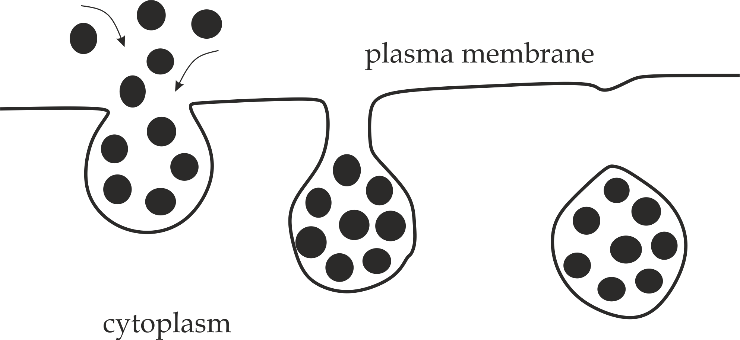

***Fig 1.12*** *Mechanism of bulk transport*

**Types of Bulk transport:**

Bulk transport is normally divided into **two (2)** types; **endocytosis**and **exocytosis.**

1. **Endocytosis**

**Endocytosis** is the movement of larger particles into the cell by the vessicle, endocytosis occurs in two form; **phagocytosis** and **pinocytosis*.***

1. **Phagocytosis**

**Phagocytosis** literally mean*“ cell eating”,*This is the type of endocytosis bywhich materials are taken into the cell in solid state.The plasma membrane invaginates to form a phagocytic vessicle enclosing the particle,The vessicle then fuses with a lysosome whose enzyme digest the particles *,* the soluble products of digestion are then absorbed into the surrounding cytoplasm.Any indigestable material may be got rid of by vessicle moving to the surface of the cell and fusing with the plasma membrane *(exocytosis).*

Example of phagocytosis includes, ***amoeba***, which feed on small organisms and ***phagocytes,*** which feed bacteria.

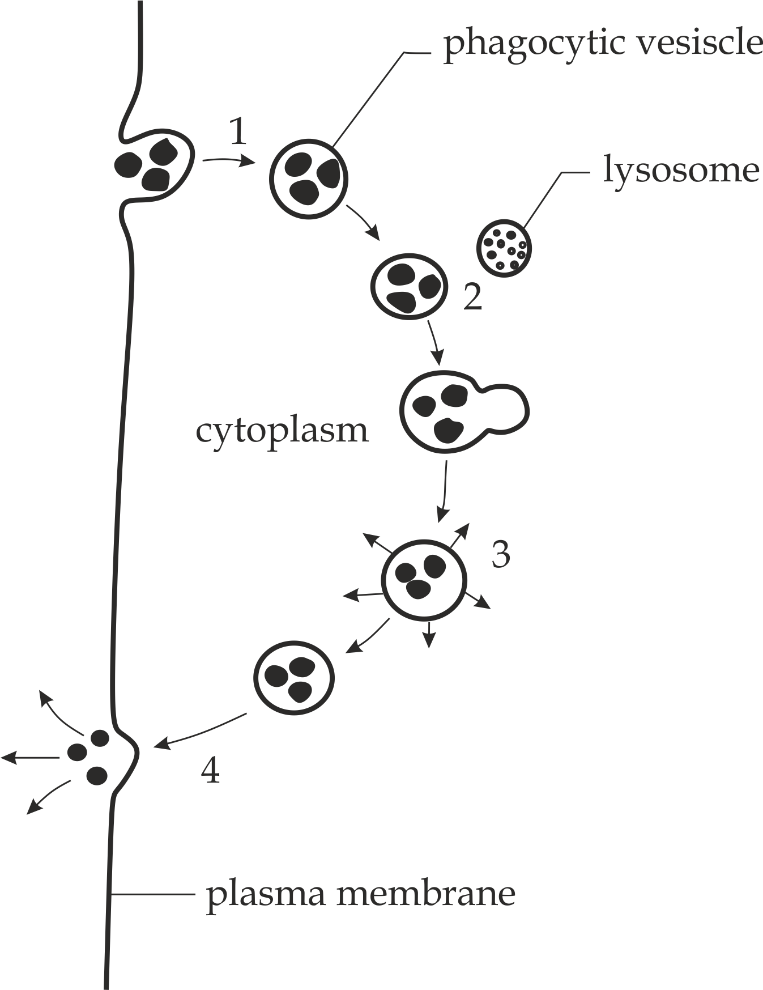

*Figure 1*

1. Larger particles are taken up by phagocytosis to form a phagocytic vesisle

2. Alsosome fuses with the vesicle and discharge its content into it.

3. lysosomes enzymes digest the particles and the products of digestion are absorbed into the surrounding cytoplasm.

4. The vesicle membrane fuses with the plasma membrane and any indigestible matter is voided.

**Figure 1** Diagram showing the phagocytic intake and digestion of particles inside a cell.

1. **Pinocytosis**

**Pinocytosis** literally means *“ cell* *drinking”,* This is the type of endocytosisby which materials are taken up into the cell in liquid state.The vesicles formed are normally very small in which case the process is known as ***micropinocytosis.***Example of pinocytosis, human egg cell which takes nutrients from the surrounding follicle cells.

1. **Exocytosis**

**Exocytosis** is literally means *“ cell vomiting”.*This is the movement of largerparticles outside the cell by vessicles*.* Examples of the exocytosis includes;Secretion of cell pruducts such as *enzymes, hormones* or *antibodies* and releasing of undigested vessicle out of the cells.

**Sample question – 18**

**Style 1 Mock coast region – 2020/ Biology**

1. Illustrate and discuss the “**fluid mosaic model** “of a biological membrane.
2. Describe **two (2)** methods in which materials passes across cell membrane.

**Style 2: Tahossa Dar Zone 2019**

* Study the diagram below and then explain the processes taking place in **1**, **2**, **3** and **4**.







***Bonus conceptual question***

**Tabora region Mock 2021**

How are the following processes important in the cell?

1. Phagocytosis
2. Pinocytosis
3. Exocytosis

**Hints**:

* Explain a vivid example in each process.

**Table 1.4 Differences between Phagocytosis and pinocytosis:**

|  |  |
| --- | --- |
| **Phagocytosis** | **Pinocytosis** |
| i. Materials are taken in solid state, | i. Materials are taken in liquid state. |
| ii. Phagocytic vesicles are larger in diameter.i.e 1 - 2µm in diameter. | ii. Pinocytosis vesicles are smaller in diameter. i.e. 0.1 – 0.2µm in diameter. |
| iii. It requires lysosomes for digestion. | iii. It does not require lysosome for digestion. |
| iv. It is associated with exocytosis. | iv. It is not associated with exocytosis. |

**Adaptations of cell membrane**

The cell surface membrane is speciliazed to its functions due to the following adaptive features:

1. Presence of many microvilli which increases the surface area for absorption.
2. Presence of the phospholipid bilayer which facilitates the passage of non polar molecules and also give the fluidity and flexibility of the membrane.
3. Presence of transport proteins to allow the passage of polar molecules.
4. Presence of cholesterol which regulates the fluidity and flexibility of the membrane.
5. Presence of glycolipids and glycoprotein which act as cell recognition sites.
6. Presence of proteins with specific shapes makes the membrane a receptor site for chemical stimuli such as hormones .
7. It is very thin membrane for rapid diffusion of materials.

**Functions of cell membrane**

1. It covers the surface of every living cell and act as a barrier which separates the cell from the external environment.
2. It controls the movement of materials in and out of the cell by selective permiability
3. It functions as a receptor site for hormones and neurotransimitters stimili.
4. It functions as a cell recognition site through glycoprotein and glycolipid.
5. It functions as enzyme which carriers the metabolic reactions.
6. It functions as a juction between two adjacent cells to perfom the common fuction.

**Sample question – 19**

**Style – 1: Pre – Mock Lindi and Mtwara 2022**

* The plasma membrane is usual said to be selectively permeable, why and how is it so?

**Hints**:

Because, it controls the movement of only certain molecules (not all molecules are free to diffuse) in and out of the cell, that is why; the plasma membrane is said to be selectively permeable. This is achieved by the components with charges such as proteins and phospholipids which repel substances with similar charges.

**Style 2: Mzumbe Gauging 2020**

* In six (6) points, explain what would happen if the plasma membrane of a cell is severely damaged.

**Hints:**

Oppose the functions of the cell membrane**.**

**Style 3: Necta 2012**

1. State any four (4) functions of lipid in living organism.
2. Outline four (4) roles of plasma membrane of a cell.



1. **CYTOPLASM**

**Cytoplasm** is the space between the cell membrane and the nucleus which is filled with translucent, homogenous and colloidal fluid*.* It includes all contents inside the cell membrane excluding the nucleus while **protoplasm**inludes cytoplasm, plus, the nucleus of the cell*.***The *c*ytosal** is the part of thecytoplasm that is not occupied by any organelle, it mainly consists of organic molecules, salts and water.i.e. The fluid that remains when all organelles are removed, The term “ *cytoplasm*” was originated by **Rudolf Von Kolliker**in **1863** as shown in *Fig 1.13*.

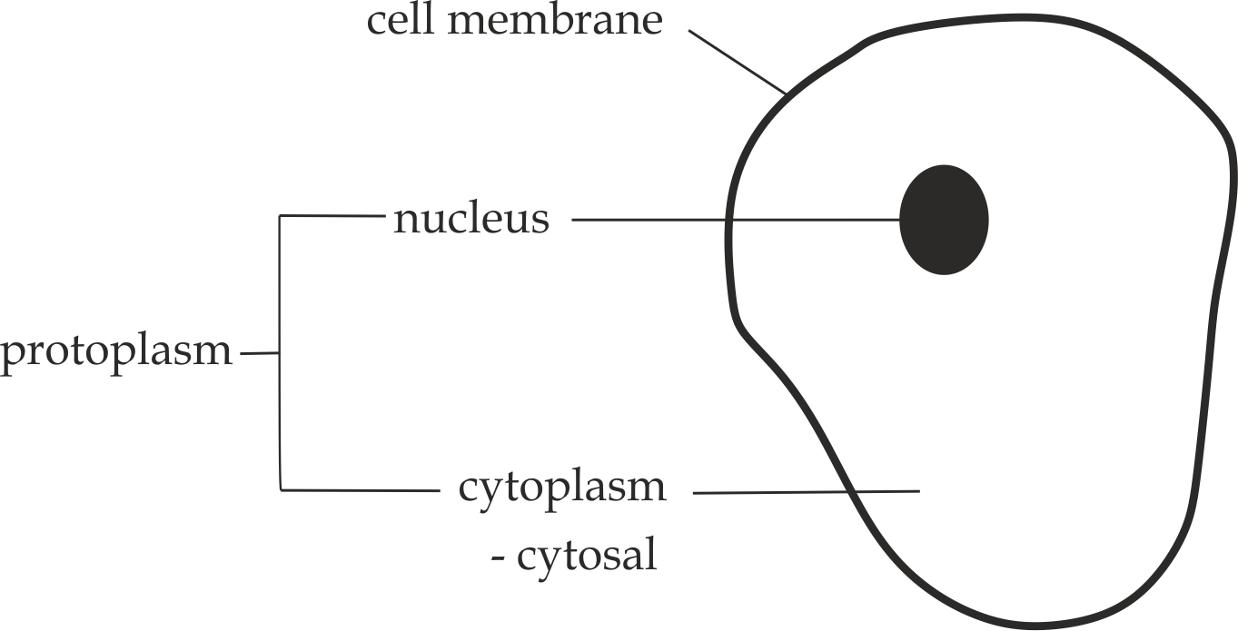

***Fig 1.13*** *Cytoplasm and protoplasm*

**Structure of cytoplasm**

**Cytoplasm**of the cell contains various chemical components, including:

* The liquid part of cytoplasm is about90 per cent water with amino acids, salts and sugar dissolve in it to form a solution.
* Soluble organic molecules such as lipid droplets and proteins which form colloidal solution.
* The cell organelles such as the nucleus, mitochondria, ribosomes and endoplasmic reticulum.
* A network of fine strands of globular proteins, known as microtubules and microfilaments, and collectively reffered to as the **cytoskeleton.**

**Sample question – 20**

**Tai question**

1. Describe the composition of the cytoplasm in living organism.
2. Distinguish between cytoplasm, protoplasm and cytosol.



**Functions of cytoplasm**

1. It provides medium for chemical reactions such as **glycolysis*.***
2. It suspends cell organelles that perform different functions such as protein synthesis in **ribosomes..**
3. It stores useful materials such as starch, glycogen and lipids.
4. It stores wastes temporary such as nitrogenous wastes.
5. It allows the movement of materials within the cell.
6. It provides shape and support to the cell.



**Sample question – 21**

**Tahossa Dar Zone -2019**

* Why is cytoplasm an important part of the cell? Give six points?

1. **THE NUCLEUS**

**Nucleus** is the largest organelle in the eukaryotic cells which controls all metabolic reactions of the cel.The nucleus is said to be **controller/ director** of cellular activities because it contains the DNA which provides instructions for synthesis of proteins including enzymes and hormones which control all metabolic reactions of the cell.It was discovered by the *Robert Brown* in 1831 in the plant cells.



**Sample question – 22**

**Mzumbe Gauging 2020**

* The nucleus is said to be the controller of cellular activities, Explain.

**Occurance**

Nucleus is found in almost all eukaryotic cells of plants and animals*.* However, certain eukaryotic cells such as the mature sieve tube in plants and mature red blood cells lack nucleus at maturity to become more effective in their functions.

**Structure of nucleus**

Structurally, nucleus is made up of the following components; Nuclear envelope, nucleoplasm, chromatin and nucleolus.

1. **Nuclear envelope**

**Nuclear envelope** is a double layer membrane which separates which separates nucleoplasm from the cytoplasm.

The roles of the nuclear membrane includes:

1. It has many pores **(3000 per nucleus***)* called nuclear pores which allow the transfer of materials between the nucleus and cytoplasm,For example, nucleotides move into the nucleus and RNA formed in the nucleus are exported to the cytoplasm.
2. It encloses and protects the inner contents of the nucleus such as chromosomes against injury.
3. The outer membrane is continous with the endoplasmic reticulum which is covered by the ribosome for protein synthesis.
4. **Nucleoplasm**

**Nucleoplasm** is a cytoplasm like material inside the nucleus.

The role of nucleoplasm includes:

1. It suspends all other components of the nucleus such as chromatin and nucleolus.
2. **Nucleolus**

**Nucleolus** is a spherical , denser and acidophillic strucure in the nucleus,The nucleolus may be one or more in number and is not bounded by any membrane.It is rich in proteins and RNA.

The role of **nucleolu*s*** includes:

1. It synthesizes Ribosomal RNA (Rrna), thus it is a “ **factory of****ribosomes***”*.
2. **Chromatin**

**Chromatin** is a coiled DNA molecule bounded by the histone proteins. During nuclear division, normally chromatin condenses into more tightly coiled threads like structure called **chromosomes** *Fig 1.14 (a), (b).*

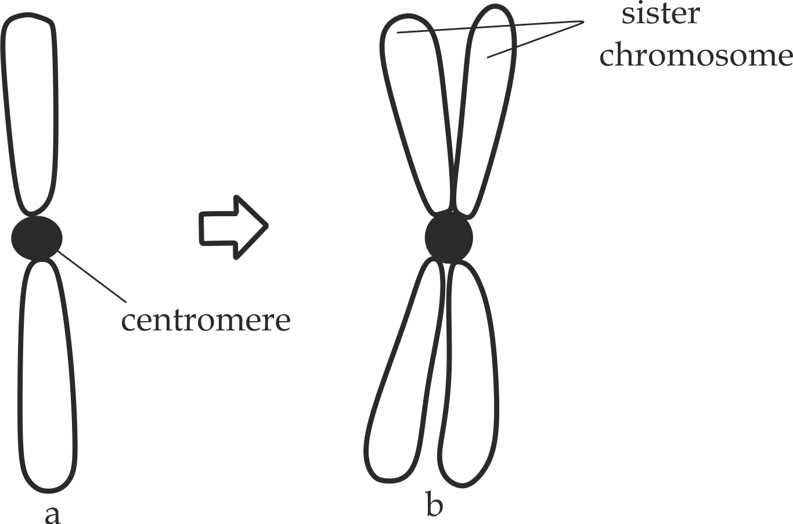

*Fig 1.14 (a) Chromatin, (b) chromosome*

**Types of chromatins:**

**Emil Heitz in 1928** concludes that, there are **two** types of chromatins basing on the intensity of staining by using nuclear stain , which are; heterochromatins and euchromatins.

1. **Heterochromatins** are denser and darky staining chromatins, usually occuring near the nuclear envelope and around the nucleolus.

Role of heterochromatins:

* They contain proteins which prvide support and protection to the DNA.

1. **Euchromatins** are diffused and lightly staining chromatins,Up to date 90% of the total chromatins are euchromatins, usually occuring at the centre of the nucleoplasm.

Role of euchromatin:

* They contain DNA which is genetically active for transcription process.

***Did you know?***

***“If your DNA in the chromatin was to be stretched out, it would go from the earth to the moon and back 6,000 times”.***



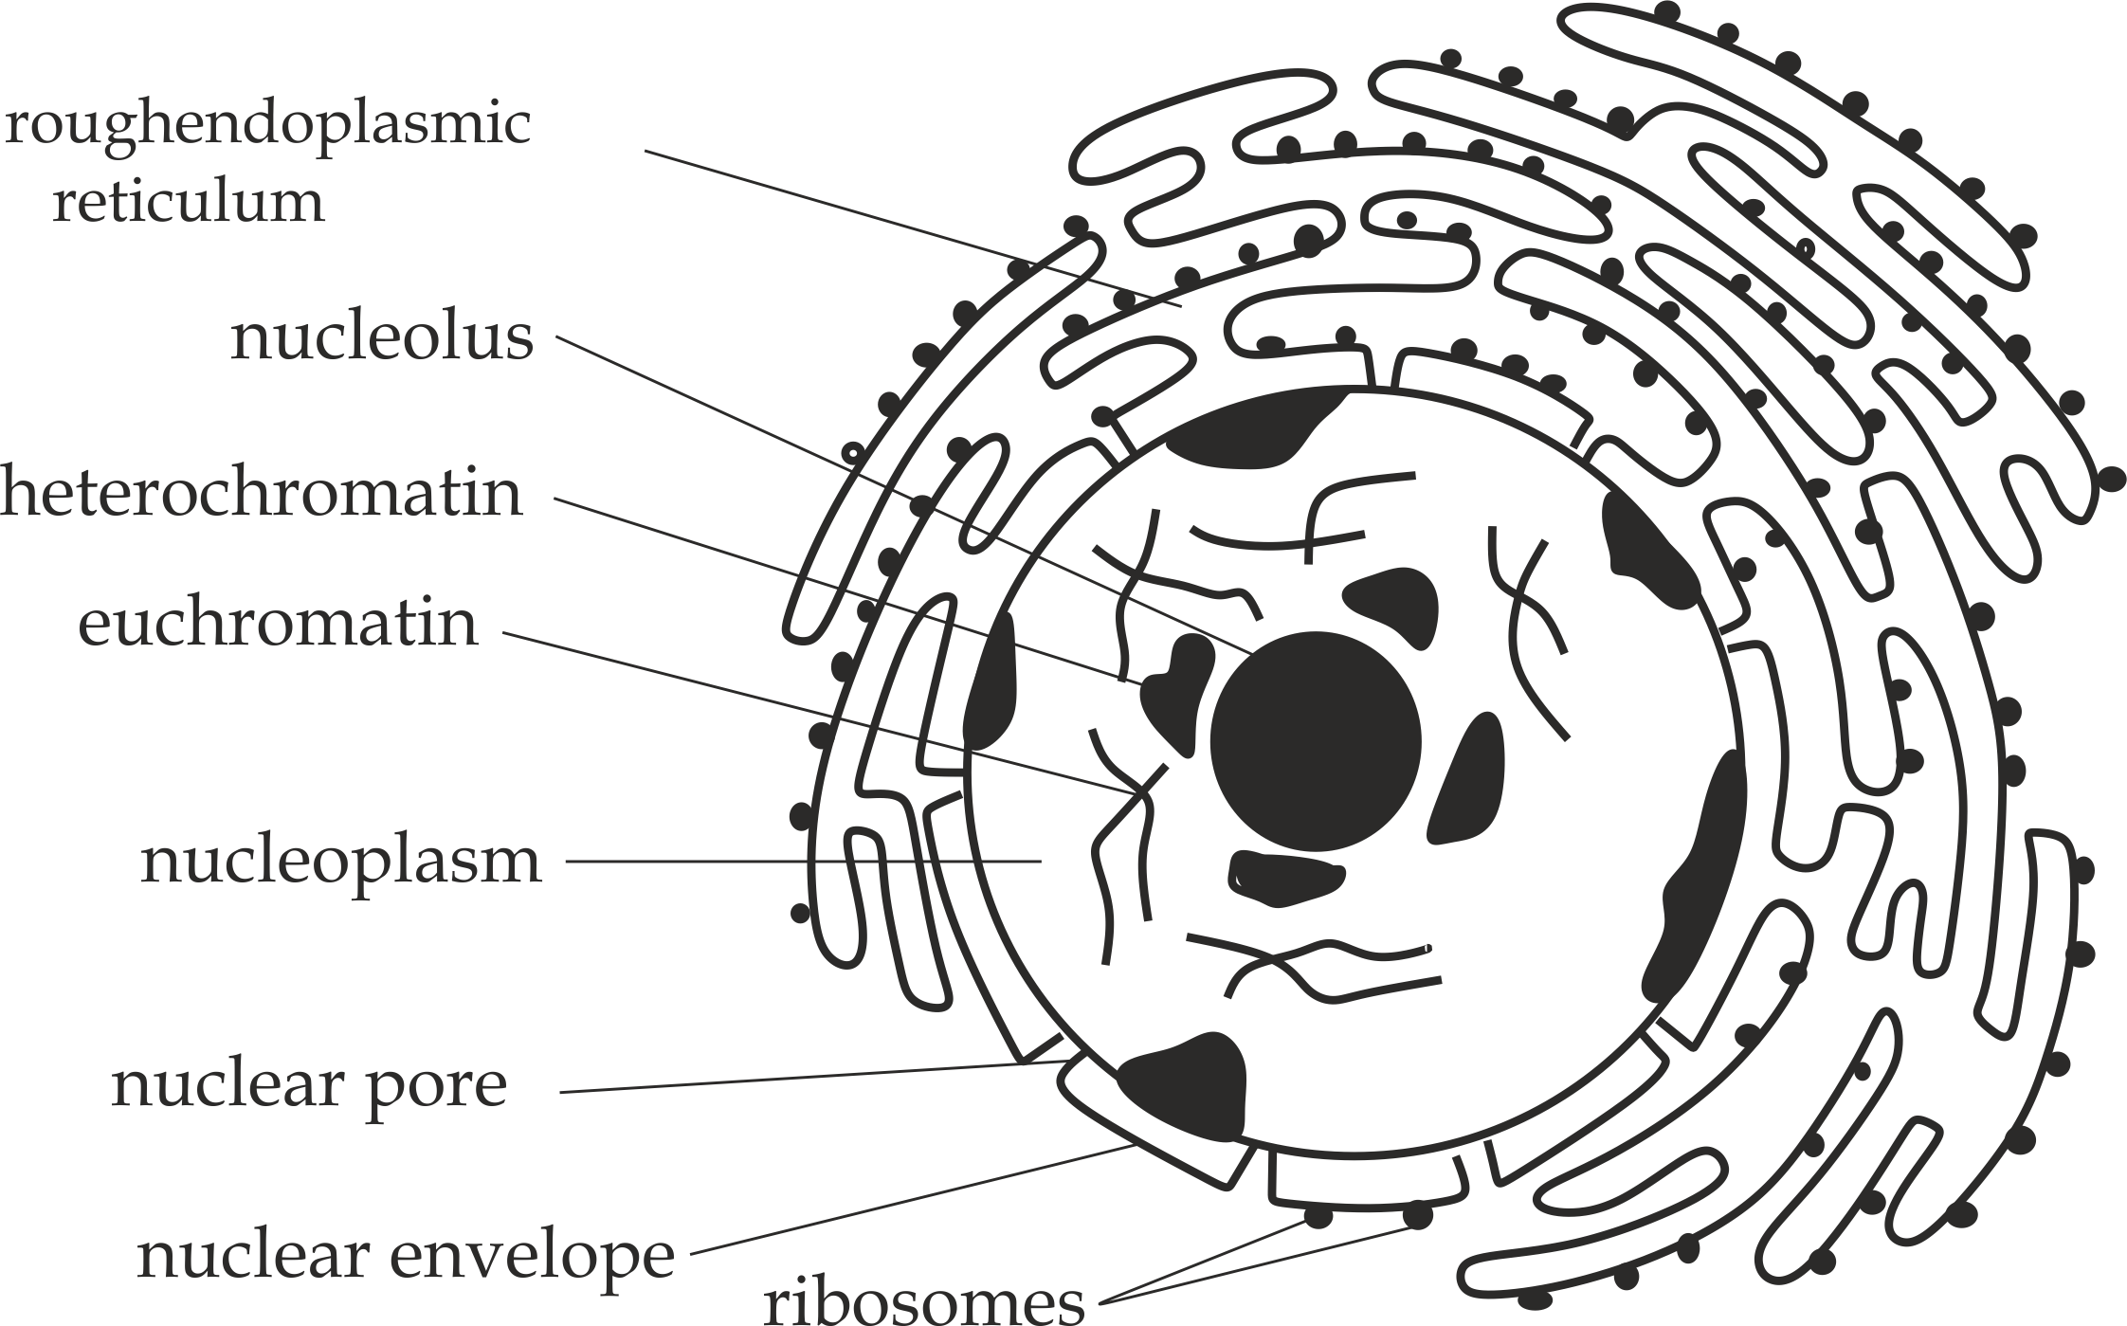

***Fig 1.15*** *Structure of the nucleus*

**Functions of nucleus**

The following are the functions of the nucleus in the cell:

1. It controls all ***metabolic activities*** of the cell.If the nucleus in the cell is removed or damaged, the protoplasm ultimately dries up and dies.
2. It contains the ***genetic materials*** *(nucleic acid)* of the cell in form of chromosome, hence, it transimits the genetic informations from the parent to the offspring.
3. It controls **protein synthesis** ,i.e.It synthesizes ***RNA*** *(transcription).*
4. It controls ***cell division*** when required, since DNA replication is essential for cell division.

**Sample question - 23**

**Style 1: Necta 2014 /Biology 1**

* Study the structure represented by ***Figure 1*** and

then answer the questions that follow:

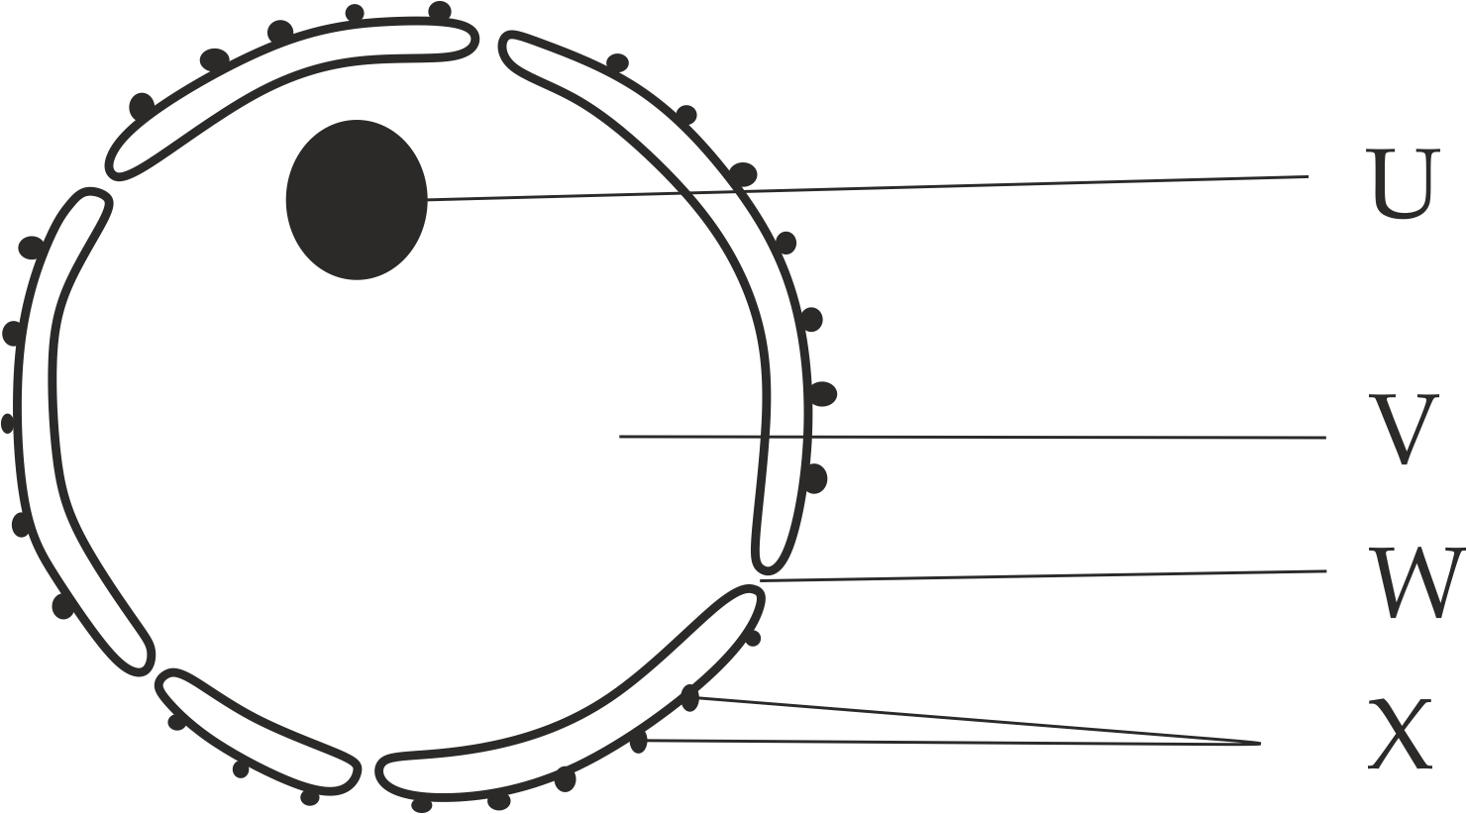

**Figure 1**

1. Name the structure represented by ***Figure*** *1.*
2. Identify the parts labeled **U, V, W** and **X.**
3. What role does each of the parts **U, V, W** and **X** plays?.
4. Enumarate four roles played by the structure represented by the ***Figure 1***.

**Style 2: St. Anthony’s sec school 2014**

1. Cells have nuclear membranes, Outline the main importance of this membranes in cells.
2. Outline the functions of a nucleus.
3. Point out two similarities and two differences between animal and plant cell.



1. **MITOCHONDRION**

In this part the following aspects should be discussed:

**D**efinition

**S**tructure

**O**ccurance

**A**daptations

**P**rokaryotic nature

**S**ymbiotic nature

**F**unctions

**Mitochondrion** *(Plural mitochondria)* is the specialized organelle which provides energy to all eukaryotic cells.For this reason, it is also known as ***“ power house of the cell”***.

**Structure of mitochondrion**

Mitochondrion vary in shape and size but are usually sausage shaped with a diameter of approximately ***1µm***.It is bounded by a double membrane.The outer membrane is quite smooth and continously while the inner membrane is deeply folded into infolding known as ***cristae*** whereby stalked particles are attached which contains enzymes neccesary for chemical reactions.It also contain cytoplasmic like matrix in which cell organelles and enzymes are suspended.The cell organelles includes few and small ribosomes(70s), Circular and naked DNA and phosphate as shown in *Figure 1.16*.

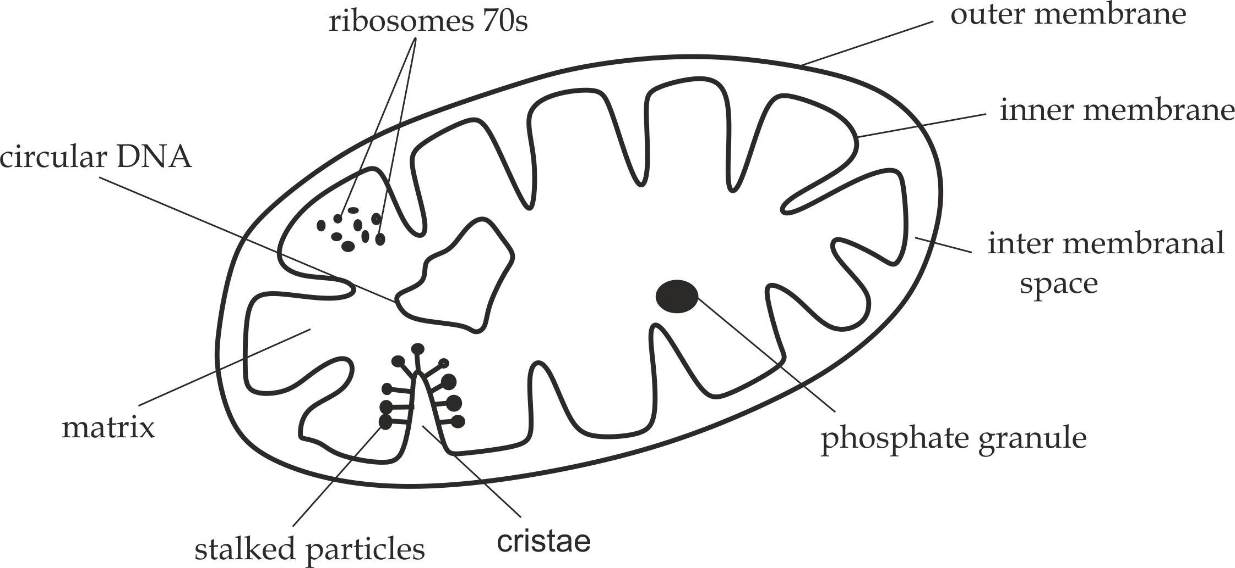

***Fig1.16*** *Structure of mitochondrion under electron microscope*

**Sample question – 24**

**Style 1: Necta 2010 / Biology 1**

1. Draw a well labelled diagram of a mitochondrion under the electron microscope.
2. Explain how the mitochondrion is adapted to the functions it performs.

**Style 2: Tahossa Annual 2022**

1. Enumerate five adaptations of chloroplast to their functions.
2. Study the structure represented by a **figure 1** below and answer the questions that follow:

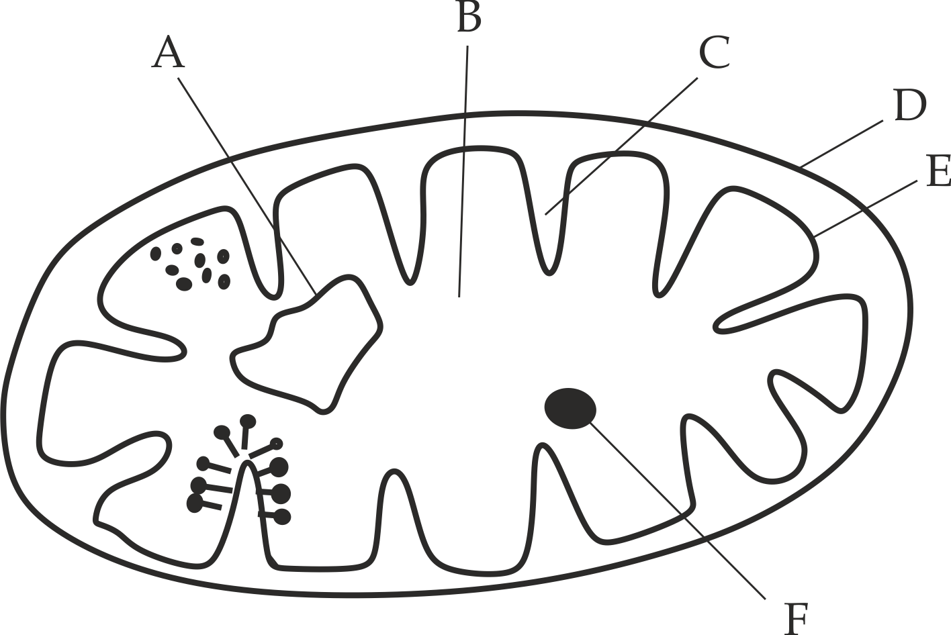

**Figure 1**

1. Name the structure represented by a **figure 1** above.
2. Identify the parts labelled A, B, C, D, E and F.
3. State the functions carried by the figure 1 above.
4. Why ribosomes are necessary to be present in a cell?



**Occurance**

Mitochondria occurs in all eukaryotic cells but the actual number of the mitochondria in the cells differs from cell to cell depending on the energy required by that particular cell.For this case,The following are cells whereby mitochondria are found in large number:

* The cells with high metabolic rate, such as **liver cells**, **muscle cells** and **brain cells*.***
* The cells whereby active transport takes place such as ***nerve cells*** and **ileum cells.**



**Sample question – 25**

**Marian Girls 2013**

* Give reasons, State where in the body of mammal you would find a large number of mitochondria.

**Remember:**

The length of mitochondrion is so variable, and the structure changes from sausage shaped to ovoid shaped within the cell in order to increase the surface area to volume ratio for diffusion of materials into and from the mitochondrion.



**Adaptations of the mitochondria**

The mitochondion is specilised to its function because:

1. Presence of **permiable membranes** which allows the movement of materials into and from the mitochondrion.
2. The inner membrane is highly folded into **criastae**that inceases its surface area for metabolic reactions such as **electron transport chain.**
3. Presence of cytoplasmic like matrix which suspends cell organelles and also site for metabolic reaction such as **Kreb’s cycle*.***
4. Presence of ***circular DNA*** for self replication and inheritance.
5. Presence of ***ribosomes*** for protein synthesis.

**Prokaryotic nature of mitochondrion**

Mitochondrion may be considered as the **prokaryotic cell** within the **eukaryotic cell**,The features that mitochondrion has in common with the prokaryotic cell include:

1. It is smaller in size, approximately ***1 – 5 µm*** in diameter.
2. It has few bounded cell organelles.
3. It has few and small ribosomes*(70s).*
4. It has Circular and naked ***DNA*** fo self replication and inheritance.
5. It has membranes for **respiration**process.



**Sample question – 26**

* Explain why a mitochondrion is considered as a prokaryotic cell?

**Symbiotic nature of mitochondrion**

The relationship that exists between the mitochondrion and the cell is symbiotic in nature.The two structures are said to be symbiotic in nature, in that mitochondrion supplies energy to the cell and cell supplies food to the mitochondria.Otherwise mitochondria can exist on their own independent on the cell due to the following reasons:

1. It has its own ***DNA*** for carrying the genetic informations.
2. It has its own**enzyme** system.
3. It has its own **ribosomes**for protei synthesis.
4. It has its own cytoplasmic like matrix.
5. It has its own food reserves.
6. It has its own energy generating system.

**Sample question – 27**

**Kilimanjaro Mock 2018**

* Explain briefly, why mitochondrion and chloroplast are endosymbiosis structures within a cell?

Give five (5) points.



**Functions of the mitochondria**

Mitochondria have the following functions:

1. It is a site for ***aerobic respiration***, hence release energy in the form of ATP for various activities in living cells.
2. It contains ***ribosomes*** for protein synthesis.
3. It contains DNA for self replication.
4. It contains food granules ***(inorganic*** ***phosphate)*** for storage of food.
5. It regulates ***calcium ions*** *(Ca+2)* concentration in the cell, because it can store and release calcium ions when required.
6. It is an intermediate site for synthesis of ***biomolecules*** such as chlorophyll or rubber in plants and steroids or fatty acids in animals.
7. **PLASTIDS**

In this part the following aspects should be discussed:

**D**efinition

**S**tructure

**O**ccurance

**A**daptations

**P**rokaryotic nature

**S**ymbiotic nature

**F**unctions

**Plastids** are double membrane bounded organelles which are found in **plant cells**only.Plastids are the largest organelles in plants.On the basis of pigments present in plastids, They are divided into **three(3)**types, **i.**The colourless**leucoplasts**which store starch, oil and proteins in plants,**ii.** the pigmented **chromoplasts** which found in flowers, leaves and fruits to attract insects in pollination and seed dispersal, **iii.**The most important ones are those containing the green pigment *chlorophyll*, known as**choroplasts**which are responsible in photosythesis.

**Chloroplasts** are the most commonly known plastids which contain chrophyll necessary for production of food by photosynthesis,For this reason, chloroplasts are the ***“* kitchens house** **of the cells*”.***

**Structure of chloroplast**

**Chloroplasts** is ovoid or disc – shaped in structure with a diameter of approximately 1μm in diameter as shown in *Figure 1.17*.It is bounded by a double membranes which are smooth and continously.It also contain cytoplasmic like stroma whereby cell organelles and enzymes are suspended, the cell organelles included few and small ribosomes (70s), circular and naked ***DNA***, starch granules, lipid droplets and fluid filled sacs called**thylakoids orlamellae** which pile up like a stalk of coins to form ***grana(****sing, granum).*The **grana** have interconnected membrane known as ***intergranal* lamella.**The chlorophyll pigments and carotenoids are present in ***thylakoids*** and **grana** for trapping sunlight in photosynthesis.

**Occurance**

Chloroplasts are found in green parts of plants, mainly in **leaves mesophyll** whereby high rate of *photosythesis* occurs.

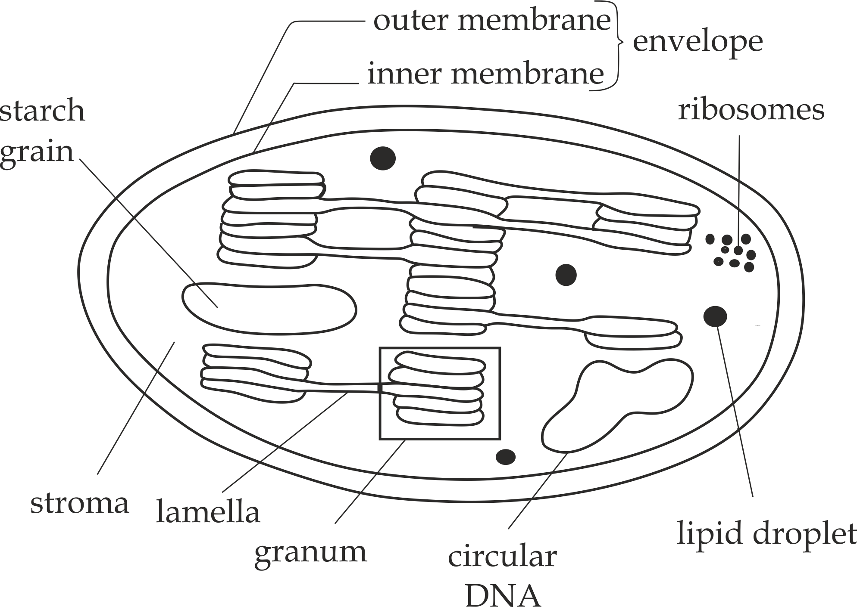

***Fig 1.17*** *Structure of chloroplast under electron microscope*

**Sample question - 28**

**Style 1: Necta 2010**

1. Draw a large, well labelled diagram of a chloroplast of higher plants.
2. How is the chloroplast structure related to its function?

**Style 2: Dar Mock 2018**

The diagram below represents the structure of chloroplast.

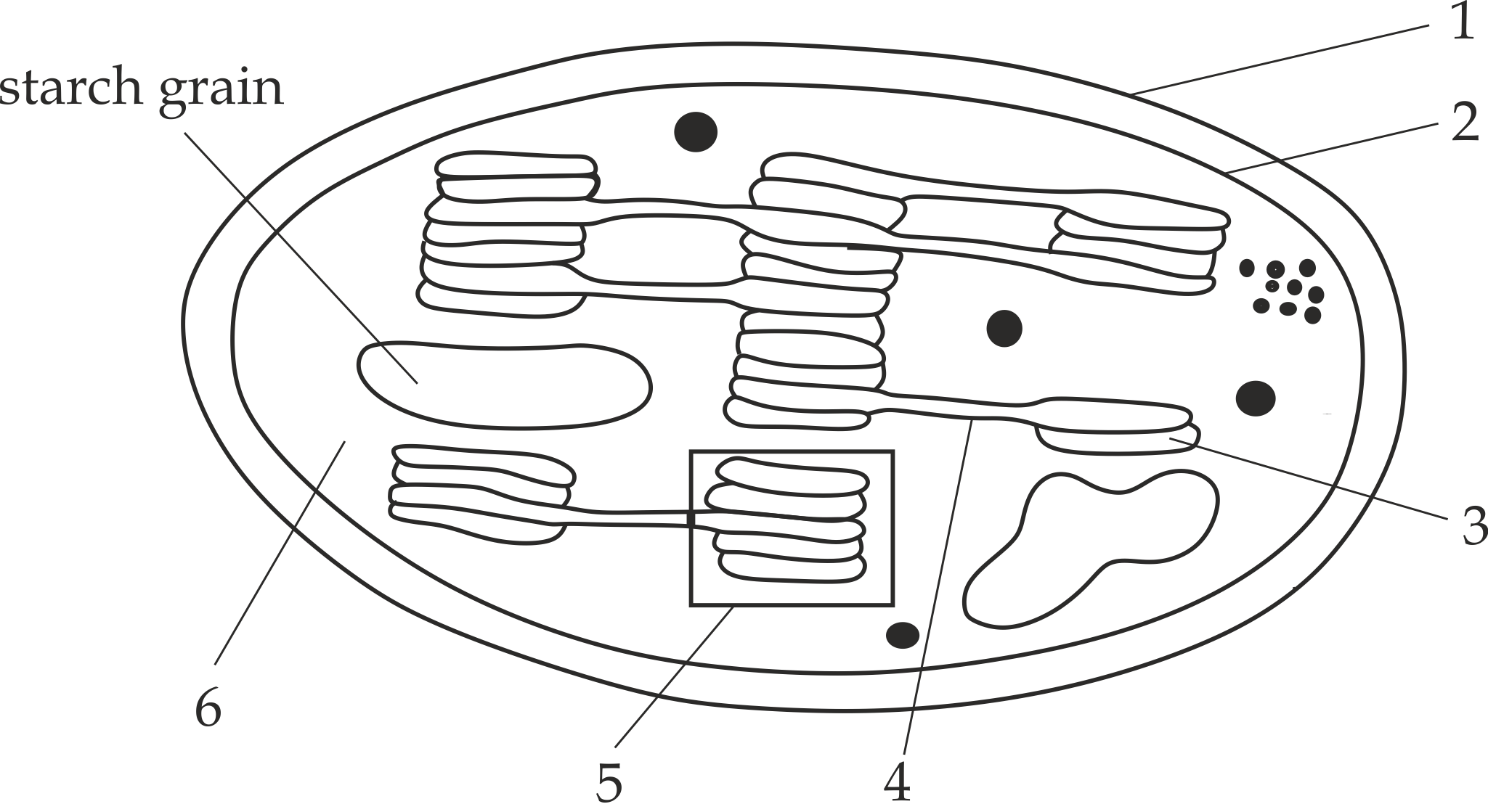

1. Name the parts labelled 1 – 6.
2. What reaction of photosynthesis occurs in structure 5 and 6?



**Adaptations of the chloroplast**

The chloroplast is specialised to its function because:

1. Presence of **permiable membranes** which allow the movement of materials into and out of the chloroplast.
2. Presence of cytoplasmic like **stroma** which suspends cell organelles and also site for metabolic reaction such as dark reaction.
3. Presence of **circular DNA** for self replication and inheritance.
4. Presence of **ribosomes** for protein synthesis.
5. Presence of **grana** which hold photosystems and their chlorophyll in proper position for trapping of light.
6. Presence of the large number of **chlorophyll** and **carotenoidspigments** which allow the maximum absorption of sunlight in photosynthesis.

**Prokaryotic nature of chloroplast**

**Chloroplast** may be considered as the prokaryotic cell within the eukaryotic cell.The features that chloroplast has in common with the prokaryotic cell include the following:

1. It is smaller in size, approximately ***1 - 5µm*** in diameter.
2. It has fewer membrane bounded organelles.
3. It has few and small ribosomes, i.e *70s ribosome.*
4. It has circular and naked DNA.
5. It has membrane for metabolic process, such photosynyhesis.

**Symbiotic nature of chloroplast**

The relationship that exists between the chloroplast and the cell is symbiotic in nature.The two structure are said to be symbiotic in nature, in that chloroplast provides food to the cell and cell suplplies raw materials for synthesis of food such as water and carbondioxide gas and minaral ions to the chloroplast.Otherwise chloroplast can exist on its own independent on the cell due to the following reasons:

1. It has its own ***DNA*** for self replication and inheritance.
2. It has its own ***enzyme*** system.
3. It has its own ***ribosomes*** for protein synthesis.
4. It has its own cytoplasmic like ***stroma*** which suspend cell organelles.
5. It has its own ***food reserves*** for storage of food.
6. It has membrane for metabolic process, such as photosynthesis.

**Functions of the chloroplast**

1. The chloroplast is the fundamental site for ***photosynthesis***.
2. It is the site for ***protein synthesis*** due to the presence of ribosomes in the stroma.
3. It is the site for ***storage of food*** due to the presence of starch grains.
4. It contains DNA for *self replication*

**Table 1.5 Differences between mitochondrion and chloroplast**

|  |  |
| --- | --- |
| **Mitochondrion** | **Chloroplast** |
| i. It is responsible for respiration. | i. It is responsible for photosynthesis |
| ii. It is a sausage shaped in structure. | ii. It is ovoid shaped in structure. |
| iii. The inner membrane is folded into cristae. | iii. The inner membrane is smooth and continuously. |
| Iv. Grana are absent. | iv. Grana are present. |
| v. Found in all eukaryotic cells. | v. Found in plant cells only. |
| vi. It contains chlorophyll pigments. | vi. It lacks chlorophyll pigments. |

1. **GOLGI APPARATUS**

**Golgi apparatus** *(Golgi bodies)* is a system of flattened membrane bounded sacs called cisternae, together with associated vesicles called**Golgi vesicles.**Golgi apparatus named after discoverer in ***1898*** by the **Camilo Golgi**, an Italian scientist who largely specialized in microscopy.

**Structure of Golgi apparatus**

The Golgi apparatus consists of stalks of flattened membranous sacs called ***cisternae,*** together with a system of associated vesicles called ***Golgi*** ***vesicles,*** Cisternae consists of two ends; The outer convex, ***Cis – face***, closest to ER, is the receiving face and the inner concave, ***trans – face***, the releasing face, represents the exit site for most products as shown in *Figure 1.18.*

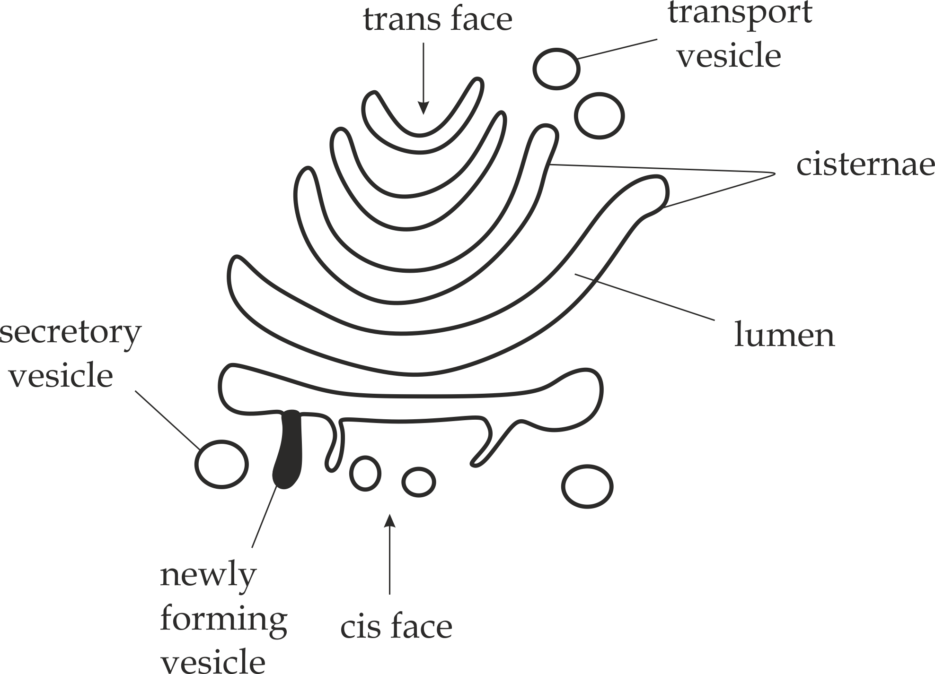

***Fig 1.18*** *Structure of Golgi apparatus*

**Sample question – 29**

**Style 1: Kaizirege and Kemebos 2019**

1. Define the term “organelles“.
2. Briefly describe the structure of Golgi apparatus and state three (3) functions of it.

**Style 2:** **Tahossa Ilala region 2020**

* Study the structure represented by the **figure 1** and then answer the questions that follow.

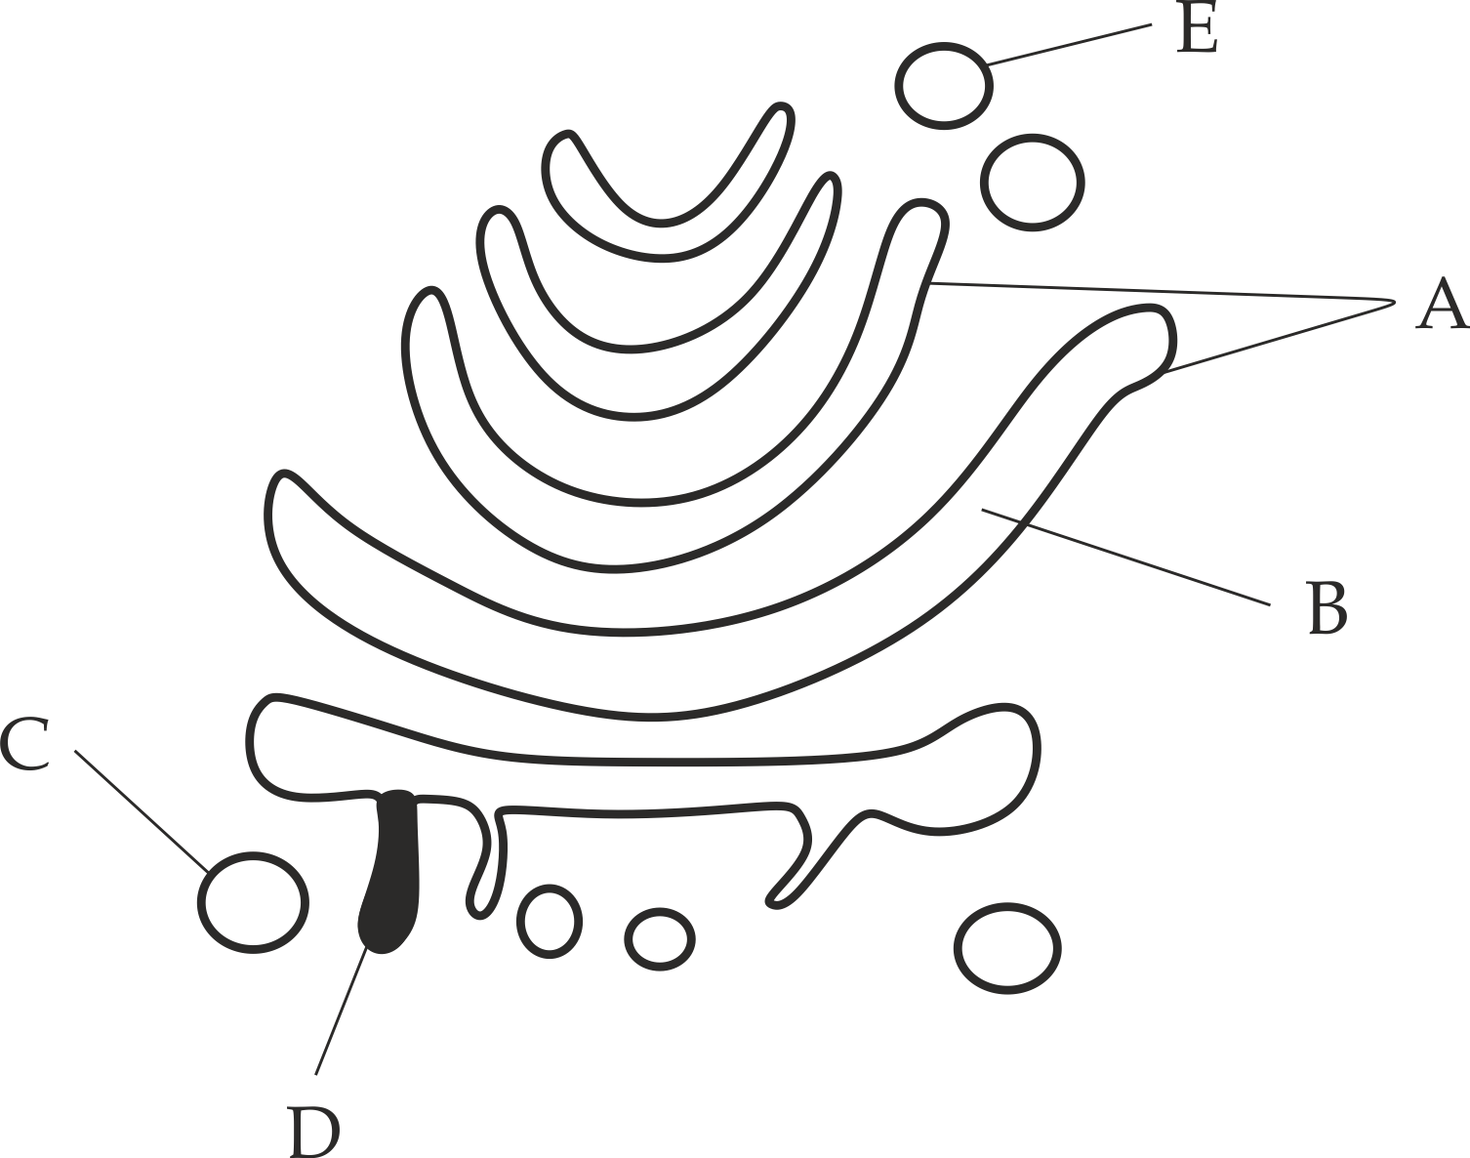

**Figure 1**

1. Name the structure represented by the **figure 1.**
2. Identify the parts labelled A, B, C and D.
3. State **three** functions of the structure represented by the **figure 1.**



**Occurrence**

Golgi apparatus occur in almost all eukaryotic cells, Each animal cell containing one Golgi apparatus especially in mucus secreting cells such as ileum cells , Respiratory cells .

While plant cells contain several hundred because the Golgi bodies are involved in the synthesis and maintenance of plant cell wall, Golgi apparatus is absent in **bacteria** and **blue green algae*.***

**Function of Golgi bodies**

The mnemonics for the functions of the Golgi apparatus is the word itself “**GOLGI**”.

**G** – Gari (transport)

**O** – Wall

**L** – Lysosome

**G** – Glycoprotein

**I** – Secretory vesicle



**The following are the functions of the Golgi apparatus:**

1. They transport materials made by the endoplasmic reticulum such as ***proteins*** and ***lipids.***
2. They are involved in the formation of ***primary cell wall*** in plants, i.e. during cytokinesis cell plate is formed by secretion of Golgi vesicles.
3. They synthesize ***lysosomes,*** i.e. the mature end of Golgi cut off small vesicles which are filled with enzymes formed by ER to form a primary lysosomes.
4. They form ***glycoproteins*** such as mucin by adding carbohydrates part to the protein.
5. They produce ***secretory vesicles*** which contain cellular secretions, e.g. enzymes.



**Sample question -30**

**Tusiime sec school/ Mid-term Exam 2014**

1. On the basis of function and structure give similarities and differences of Golgi apparatus and endoplasmic reticulum.
2. Outline four (4) functions of Golgi apparatus.
3. **ENDOPLASMIC RETICULUM**

**Endoplasmic reticulum *(ER)*** is a network of flattened membranes bounded sacs called ***cisternae*** forming “sheets” or “tubules”. Depending upon the presence and absence of ribosomes on the surface of **ER**, There are **two (2)**types; i. **RER***(* Rough Endoplasmic reticulum*)* with ribosomes attached to its surface,ii. **SER***(* Smooth Endoplasmic reticulum*)* without ribosomes.

1. **Rough Endoplasmic reticulum(RER)**

**RER** is the type of endoplasmic reticulum(ER) which is covered by the ribosomes as shown in *Figure 1.19.*

**Key concept:**

* **RER** exist in flattened membrane sacs called **cisternae*.***
* **RER** present nearby the **nuclear envelope*.***
* **RER** are found in protein secreting cells such as **plasma cells** which secrete antibodies and **enzyme secreting cells**such as pancreaticenzymes.

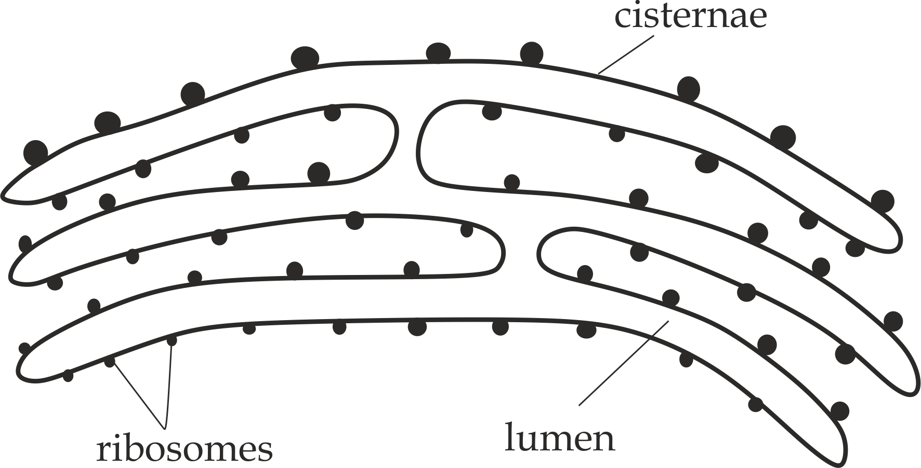

***Fig 1.19*** *Rough endoplasmic reticulum (RER)*

**Sample question – 31**

**Kaizirege sec school 2018**

* Draw a clearly well labelled diagram of a rough endoplasmic reticulum.



1. **Smooth Endoplasmic reticulum/SER**

**SER** is the type of endoplasmic reticulum wich is not covered by the ribosomes as shown in *Figure 1.20*.

**Key concept:**

* **SER** exist in **tubular form**.
* **SER** occur nearby the **cell surface** **membrane.**
* **SER** are found in lipid secreting cells such as **liver cells** which secretes cholesterol , **interstitial cells** of the gonads wich secretes steroid sex hormones such as oestrogen, progesterone and testosterone and **adrenal cortex** wich secretes glucocorticosteroid hormone.

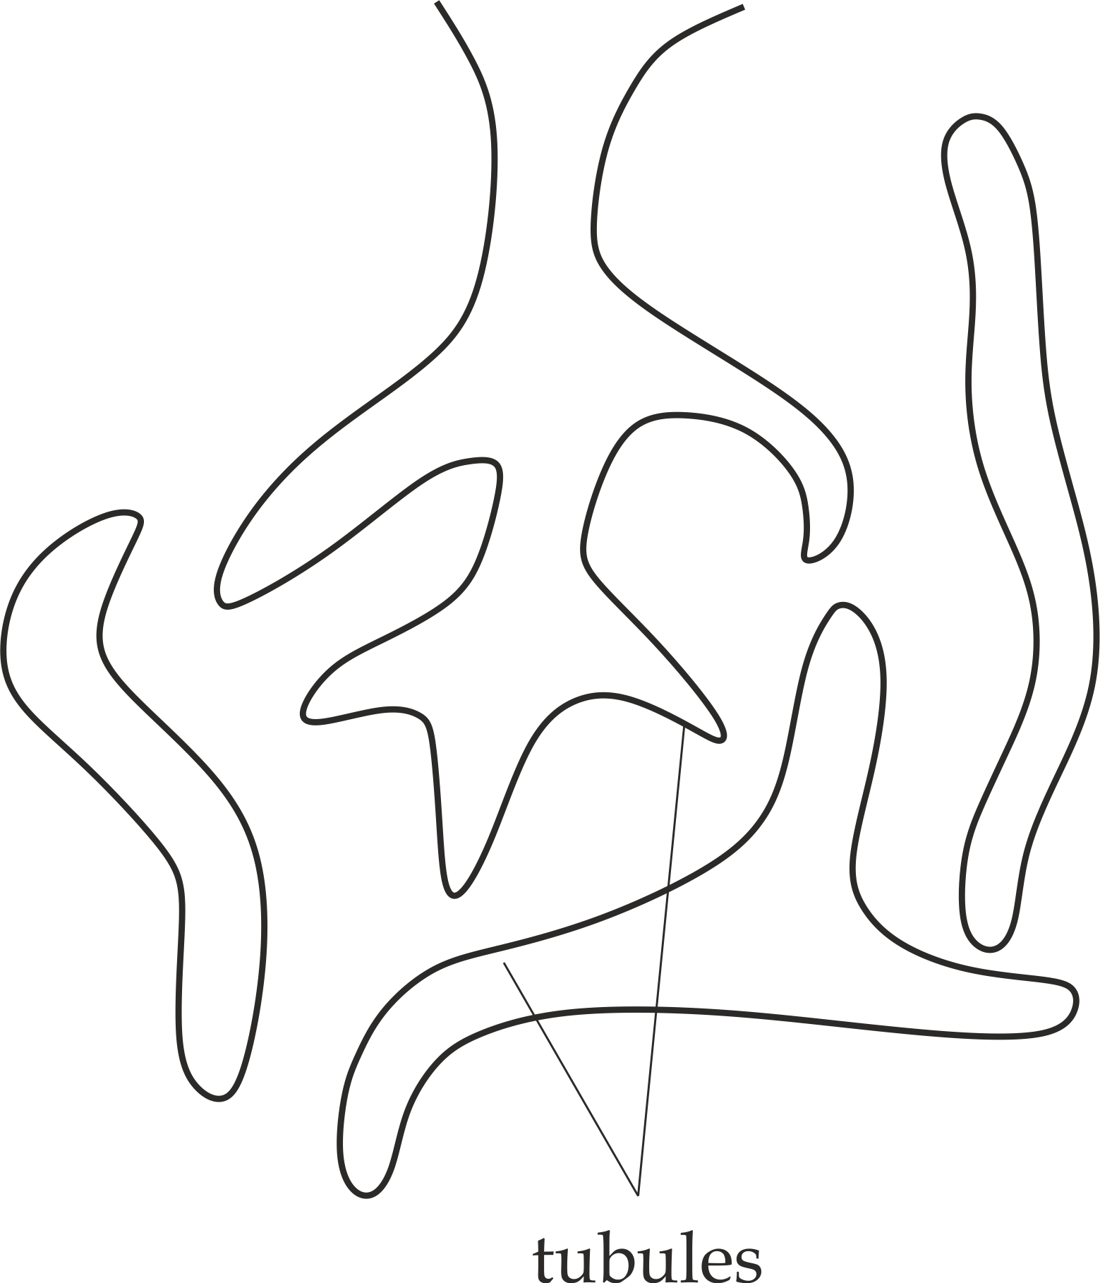

***Fig 1.20*** *Smooth endoplasmic reticulum*

**Sample question – 32**

**Kilimanjaro Mock 2009**

* Where in a human body do you find highest concentration of the following cell organelles; and why?

1. Peroxisomes
2. SER
3. RER



**Functions of Endoplasmic Reticulum**

1. **Rough Endoplasmic Reticulum**
2. They are sites for protein synthesis such as **digestive enzymes** and**hormones** due to the presence of ribosomes.
3. They provide pathways for transportation of proteins through the cell.i.e. Enzymes synthesized on the ribosomes enter in the lumen of *rough ER* and transported to the golgi apparatus which then discharge as *vesicles* which can retain in the cytoplasm as lysosome and peroxisome or removed from the cytoplasm as secretory proteins such as **digestive****enzymes, antibodies.**
4. They form *gycoproteins* by adding carbohydrates to the proteins, a process called **glycosylation***.*
5. **Smooth Endoplasmic Reticulum**
6. They are used to synthesize lipids such as cholesterol needed to make cell membrane, and steroids needed to make steroid hormones such as **oestrogen**.
7. They are used in **detoxification**, For example; **Smooth ER** of liver helps in detoxification of various toxic or poisonous substances such as drugs including alcohol, insectisides (DDT), petroleum products and pollutants.These toxic substances make their entry in animal’s body through food, air or water.
8. They are mainly involved in the formation of **Golgi apparatus.**
9. **Both**
10. They provide structural framework of the cells thus maintain the shape of the cell.
11. They provide a large surface area for biological or chemical reactions such as **protein synthesis** and **lipid** **synthesis.**

**Table 1.6 Differences between Rough ER and smooth ER**

|  |  |
| --- | --- |
| **Rough ER** | **Smooth ER** |
| i. It is covered with ribosomes. | i. It is not covered with ribosomes. |
| ii. It is formed by the flattened sacs called cisternae. | ii. It is formed by the tubules. |
| iii. It is present nearby the nuclear envelope. | iii. It is formed nearby the cell membrane. |
| iv. It is specialized to synthesize proteins. | iv. It is specialized to synthesize lipids. |
| v. It is abundant in the protein secreting cells such as plasma cells. | v. It is abundant in lipid secreting cells such as interstitial cells of the gonads. |

1. **CYTOSKELETOL STRUCTURES**

**Cytoskeleton structures** are complex network of fibrous proteins molecules that provide internal skeleton for cells and thus maintain cell shape. Usually, the network cannot be seen with light microscope because the individual fibres are single chains of proteins, much too fine for the microscope to resolve, to see the cytoskeletal structures scientist attach ***florescent*** ***antibodies*** to the protein fibres and then photograph then under fluorescent light. The cytoskeleton structures consist of: microtubules, intermediate filaments *and* microfilaments.

1. **Microtubules**

**Microtubules** are slender, unbranched cylindricalstructures around **25nm** in diameter.

**Structure of microtubules**

These are tubular structures made up of arranged ***tubulin proteins***. There are two kinds of tubulin units, the ** – tubulin** and **β – tubulin***,* which combine to form a dimer with helically arranged subunits. The tube is hollow filled up with fluids as shown in *Figure 1.21*.

**Occurrence**

* **Microtubules** are widely distributed in the cytoplasm of the animal and plant cells.
* **Microtubules**are also found in locomotive structures, such as cilia, flagella and centrioles in the spindle.

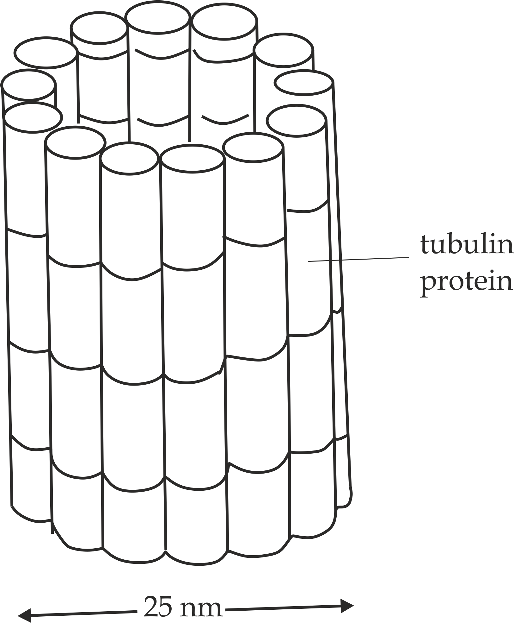

***Fig 1.21*** *Structure of microtubule*

**Functions of microtubules**

The functions of microtubules in the cell include the following:

1. They provide the internal skeleton for cells thus maintain cell shape.
2. They involved in the movement of cytoplasmic components within the cell e.g. Microtubules appear to direct the passage of Golgi vesicles towards the Centre to form cell plate during the formation of a primary cell wall in plant cells.
3. They form a framework on which the**cellulose** cell wall is laid down.
4. The microtubules in the cilium and flagella aid in the ***rhythmic*** ***movement*.**
5. The microtubules in the centrioles form **spindle fibres** during cell division that direct movement of chromosomes.e.g. This usually occurs during mitosis and meiosis nuclear type of cell division.

**Sample question - 33**

**Necta 2017 / Biology 1**

* Describe three (3) functions of microtubules.



1. **Intermediate filaments**

**Intermediate filaments** are filaments with intermediate thickness between microtubules and microfilaments around **12nm** in diameter.

**Structure of intermediate filaments**

Intermediate filaments are made up of long fibrous protein sub – units called **keratin** units coil together like threads that compose a rope to make the filaments as shown in *Figure 1.22*.

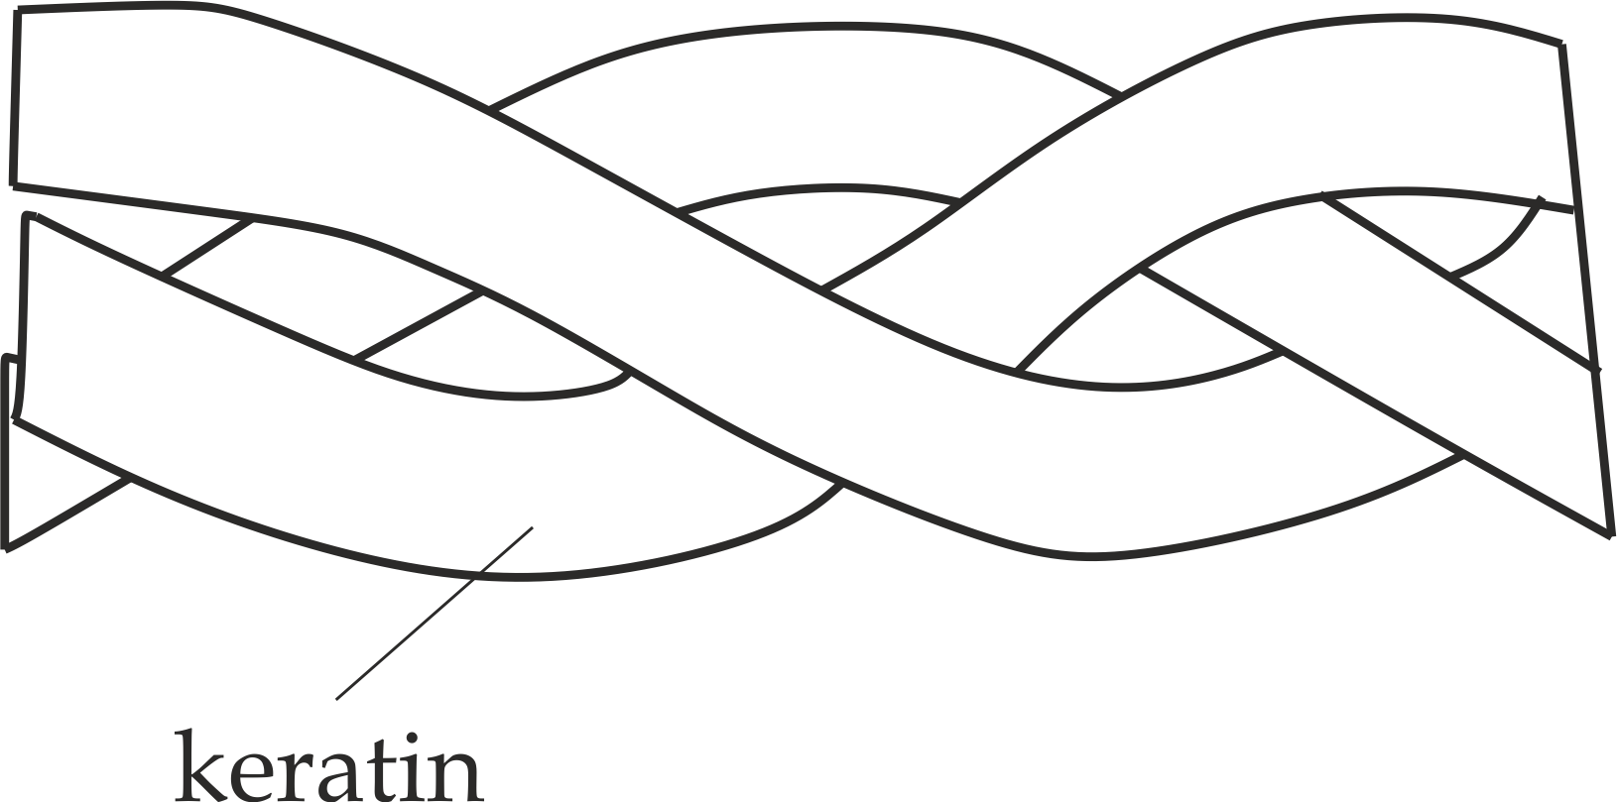

***Fig 1.22*** *Structure of intermediate filament*

**Occurrence**

**Intermediate filaments are** found in the epithelial cells of the skin and hair which exist as  – helix keratin protein.

**Functions of intermediate filaments**

1. They provide mechanical strength and support by preventing excessive stretching of the cells. For example, skin cells; resist the wear of tear because they consist of intermediate filaments.
2. **Microfilaments**

**Microfilaments** are very thin, flexible and solid strands about **5 – 7nm** in diameter.

**Structure of microfilaments**

**Microfilaments** are composed of a large amount of ***actin****.* Hence their name actin filaments. Actin filaments usually are in association with ***myosin*** which in turn consists of twisted double strands shown in *Fig* *1.23.*

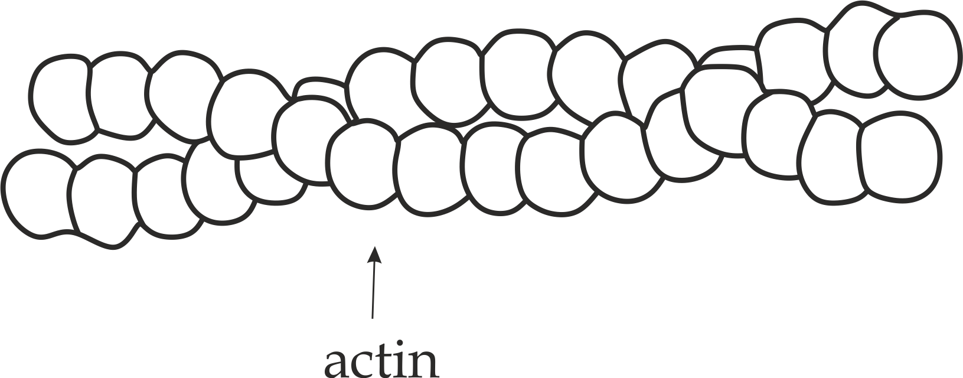

***Fig 1.23*** *Structure of microfilament*

**Occurrence**

* They are widely distributed in the cytoplasm of the cells, just below the cell membrane and at the interface between stationery and moving cytoplasm where cytoplasmic streaming is taking place.
* They are found in the muscles.

**Functions of microfilaments**

The **mnemonics** for the functions of microtubules is represented as **C4**.



**C** – **C**ytoplasmic streaming

**C** – **C**ell motility

**C** – **C**leavage

**C** - **C**ontraction

**The following are the functions of the microfilaments:**

1. They aid in **cytoplasmic streaming** such as pseudopodia movement in amoeba.
2. They aid in **cell motility** such as sperm movement.
3. They aid in **cleavage** during cytokinesis which is brought about by the constriction of a ring of microfilaments after nuclear division.
4. They aid in muscle **contraction** due to interaction between actin and myosin filaments.



**Sample question – 34**

**Mbeya Mock 2021**

* Giving three examples, explain what you understand by the term “cytoskeleton“?

1. **CILIA AND FLAGELLA**

**Cilia or flagella** are hair like extension arising from the ***basal body*** below the plasma membrane of the animal cells.

**Structure of cilium or flagellum**

Structurally, flagellum and cilium are almost identical. They are enclosed by a plasma membrane, *internally*; they contain microtubules run longitudinally. These are arranged in a precise way: There are two in the centre surrounded by a ring of nine paired ones, called **doublets**; this arrangement is described as the **9 + 2** pattern. At the base of cilium or flagellum is an elaborate attachment apparatus consisting of a basal body from which **rootlet fibres** penetrate into the deep layers of cytoplasm. The basal body is composed of a ring of microtubules with those in the cilium itself, However, the two central microtubules are absent, and the peripheral ones are in three **(triplets)** asshown in *Figure 1.24***.**

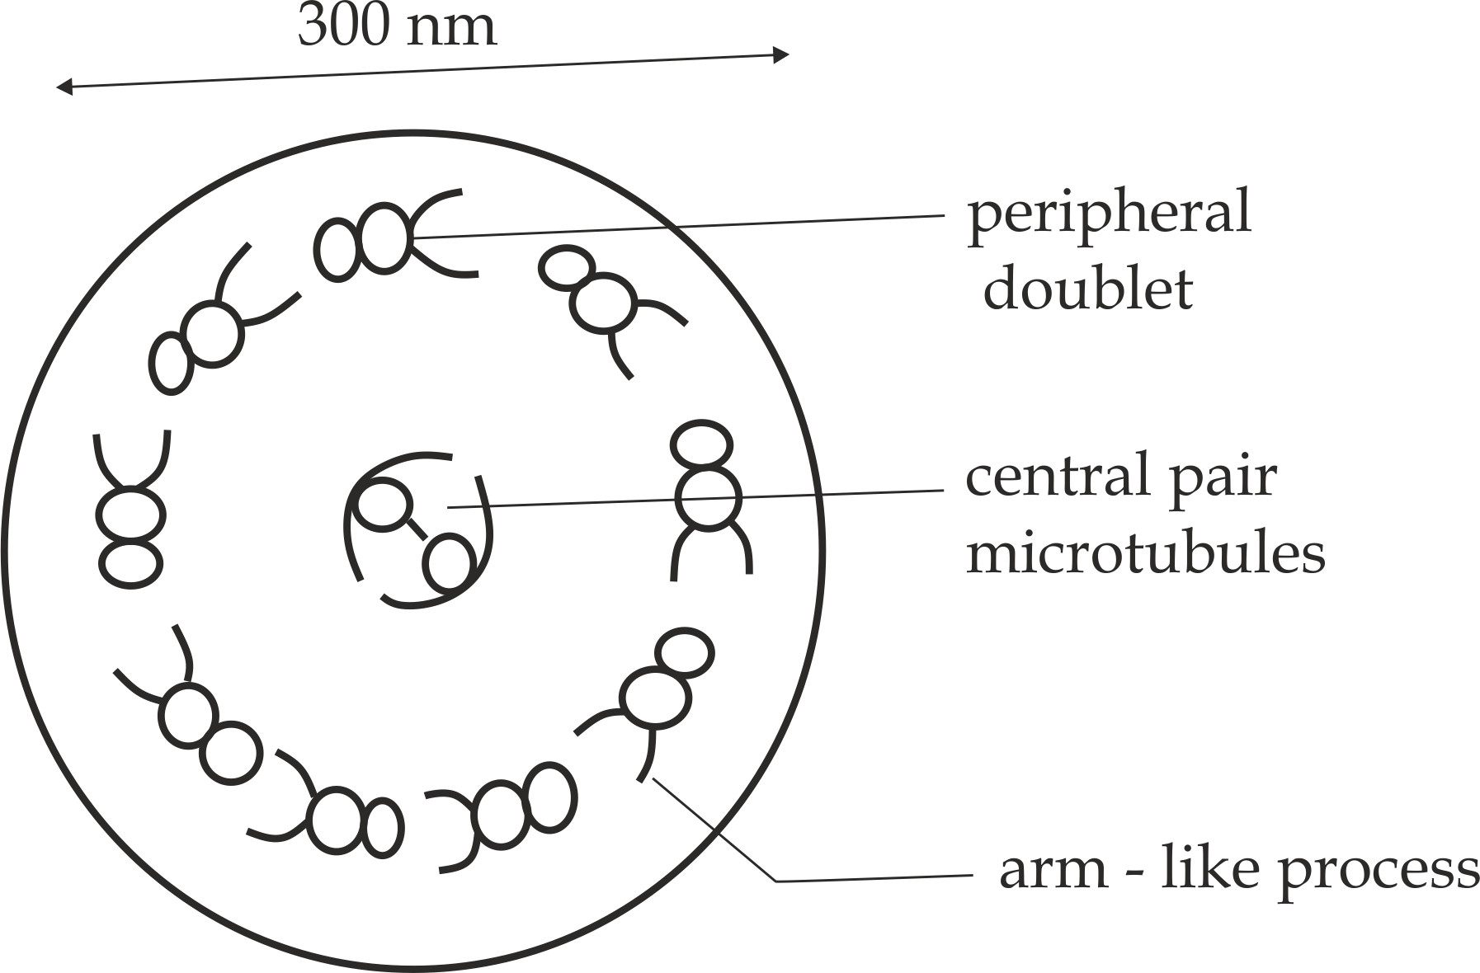

***Fig 1.24*** *Detailed transverse section of cilium or flagellum*

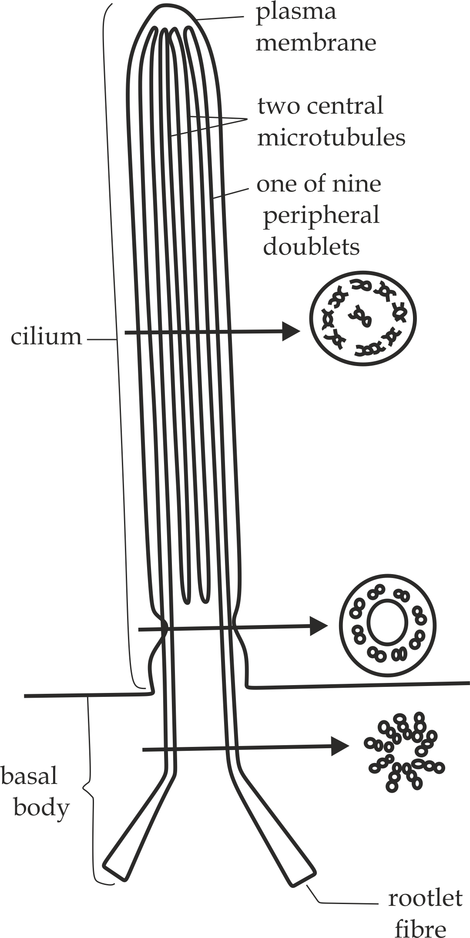

***Fig 1.25*** *Detailed longitudinal section structure of cilium or flagellum*

**Table 1.6 Differences between cilia and flagella**

|  |  |
| --- | --- |
| **Cilia** | **Flagella** |
| i. They are shorter in length. **25µm** | i. They are longer in length. **100µm** |
| ii. They occur in large number. | ii. They occur in few numbers. |
| iii. They move in coordinated manner | iii. They usually beat independently. |



**Sample question – 35**

**Marian Girls 3003**

* Describe the structure and function of cilium.

**Functions of cilia and flagella**

The functions of cilia and flagella are depending on the sites of location, which includes the following:

1. Cilia and flagella aid in the movement of the cell, For example, flagella in **sperms** and cilia in many of the unicellular organisms such as **paramecium.**
2. Cilia aid in the movement of the **trapped particles** such as dust in the respiratory tract.
3. Cilia aid in the **attachment** of some organisms on the surface such as bacteria.
4. Cilia in the **urinary tubules** enable urine to flow in one direction.
5. Cilia in the ventricles of the brain and spinal cord enable the flow of cerebral spinal fluid in one direction.

**Sample question – 36**

**Marian Girls terminal Exam 2013**

1. Compare and contrast cilia and flagella
2. List any four sites whereby cilia are found and state the function in each situation.



1. **MICROVILLI**

**Microvilli** are finger – like projections of the animal cell membrane. They are also termed as **brush borders**.

**Structure of microvilli**

Each microvillus is very thin finger like process about **1.0 µm** long and **0.08 µm** wide. It is lined with the plasma membrane and filled with cytoplasm which is continuous with that in the main body of the cell as shown in *Figure* *1.26.*

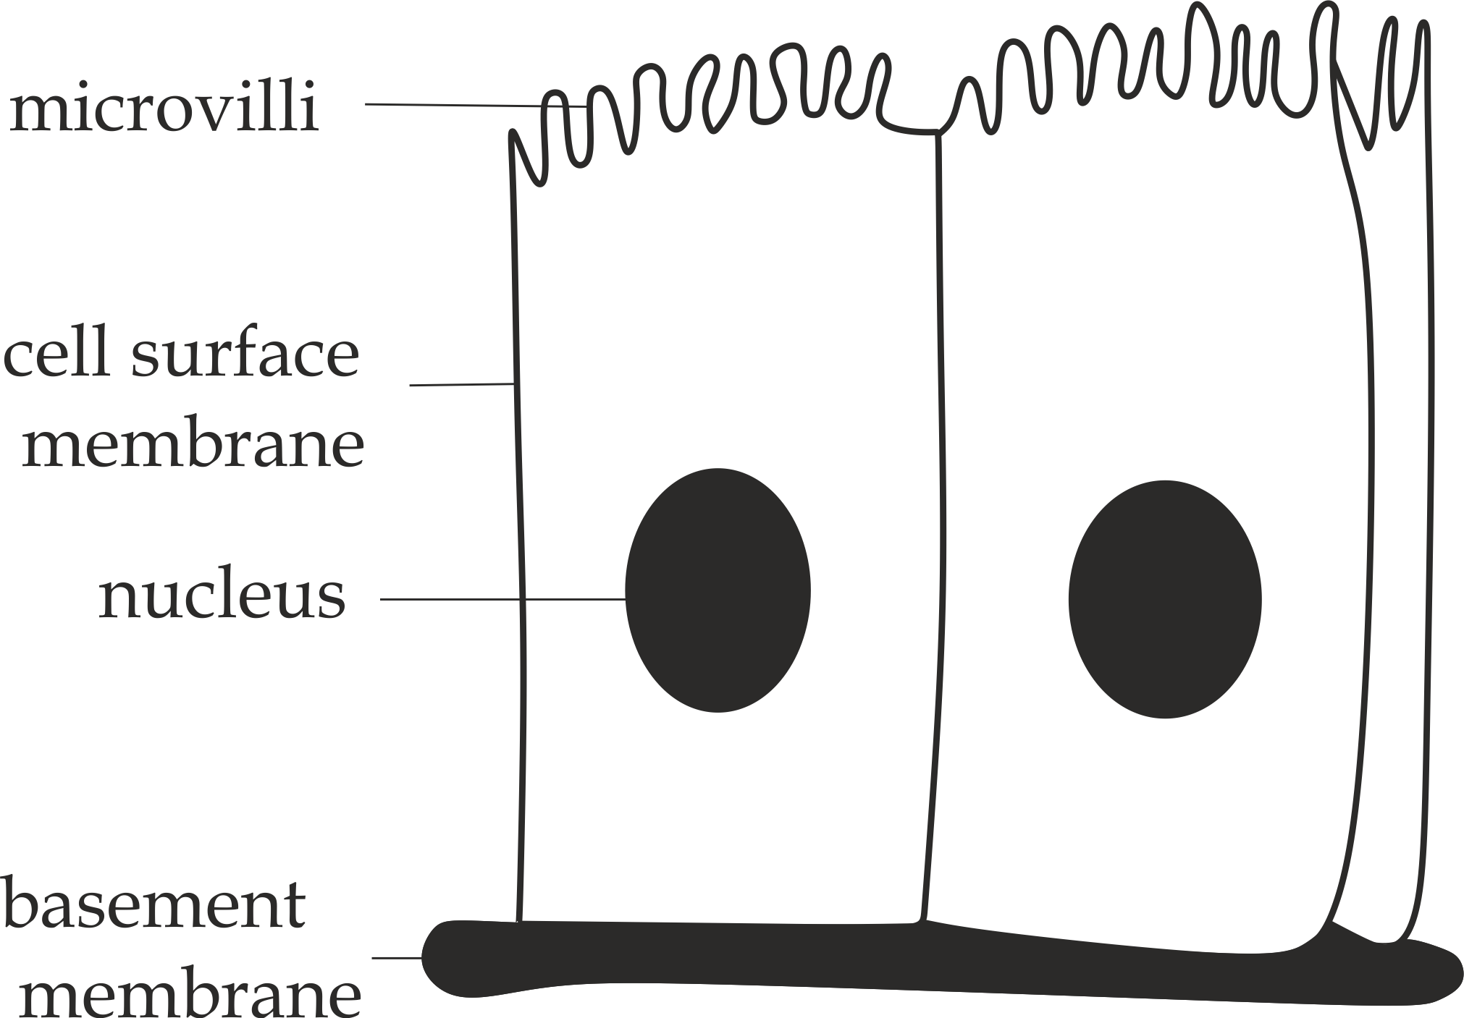

***Fig 1.26*** *Structure of microvilli*

**Occurrence of microvilli**

Microvilli are most abundant in the epithelium of kidney tubules (nephrons) and intestine.

**Function of the microvilli**

* **Microvilli** increase surface area to volume ratio for the absorption of materials such as absorption of the end products of digestion in the intestine.

**Sample question – 37**

**St Anthony’s sec school Mid-term 2006**

* Describe the structure, occurrence and function of microvilli in animal cell.



1. **LYSOSOME**

The word **Lysosome** is originated from two Greek words which are: The word ″ Lysis” means to break apart and the word ″ soma” which means body.

**Lysosome** is a single membrane bounded spherical organelle that contains digestive enzymes such as nuclease, protease and lipase, responsible for digesting and destroying unwanted matter in the cell.i.e; the main organelle of intra – cellular digestion.

**Structure of lysosome**

Structurally, **lysosome** is a small spherical vesicle, **0.2 – 0.5µm** in diameter. The lysosome is bounded by a single membrane, but no distinct internal morphology. It contains digestive enzymes such as proteases, nucleases and lipases. As many as **50** **enzymes** may be contained in a single lysosome as shown in *Figure 1.27*.

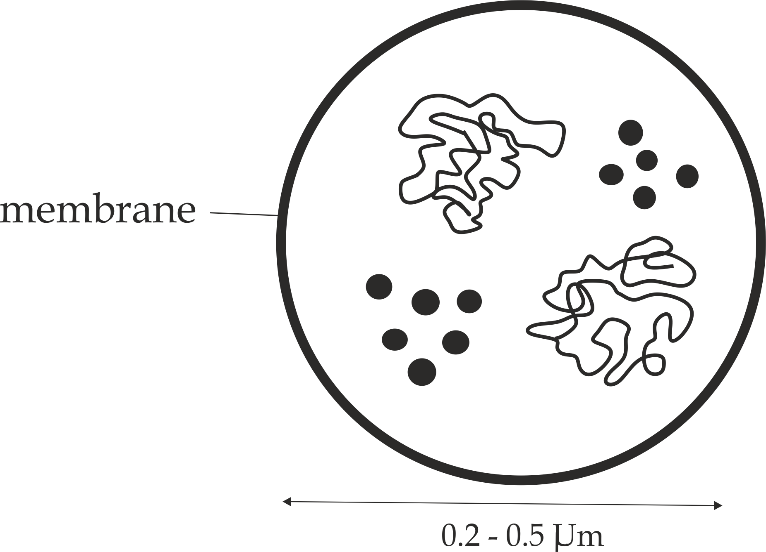

***Fig 1.27*** *Structure of lysosome*

**Occurrence**

Lysosomes are found in all animal cells except **Red blood cells** *(RBC’s).*In animals, lysosomes are most abundantly in the **white bloodcells *(****WBC’s****);*** in addition they are much numerous in epithelium of **uterus** and **lungs.** Lysosomes are only few in plants, because in plant cells, the large cell vacuoles may act as lysosomes**.**

**Site of synthesis**

The hydrolytic digestive enzymes of the lysosomes are synthesized in the **ribosomes** of the **rough endoplasmic** **reticulum** and transported to the Golgi apparatus for modification. The Golgi apparatus packs the modified and processed enzymes in the Golgi vesicles, which later bud off to form **lysosomes.**

**Sample question – 38**

**Marian Girls 2005**

* What is the main functional relationship between endoplasmic reticulum, Golgi apparatus and lysosome?



**Functions of lysosomes:**

The main functions of lysosomes in the cell include; endocytosis, exocytosis, autophagy and autolysis as shown in *Figure 1.28*.

1. **Endocytosis**

It is the digestion of materials taken into the cell.

Biological significance:

* In prevention against infections; WBC’sengulf bacteria or viruses by the phagocytosis.

1. **Exocytosis**

It is the releasing of enzymes outside the cell to digest nearby structure.

Biological significance**:**

* In mammalian fertilization**,** the lysosome enzymes present in the acrosome of sperm cells are released to digest the egg cell wall, thus, the sperm is able to enter the ovum and start the fertilization.
* In growth and development;the lysosome enzymes are released to digest the tadpole tail cells so as to change from tadpole stage into adult amphibian.

1. **Autophagy**

It is the digestion of unwanted matter or structure in the cell such as old mitochondrion.

Biological significance;

* During starvation, the lysosomes digest stored food contents such as proteins, fats and glycogen of the cytoplasm and supply necessary amount of energy to the cell.

1. **Autolysis**

It is the self-digestion of the cell by releasing its digestive enzymes within the cell. This is the reason why lysosomesare commonly known as:

**″** *Suicide - bags***”.**

Biological significance;

* In after birth**,** the uterus is gradually returns to its normal size by self-digestion of many of the cells.



**Sample question – 39**

**Tambaza high school 2021**

1. Why is lysosomes said to be suicide bags?
2. Giving reasons, state where in the body of a mammal large number of lysosomes are found?

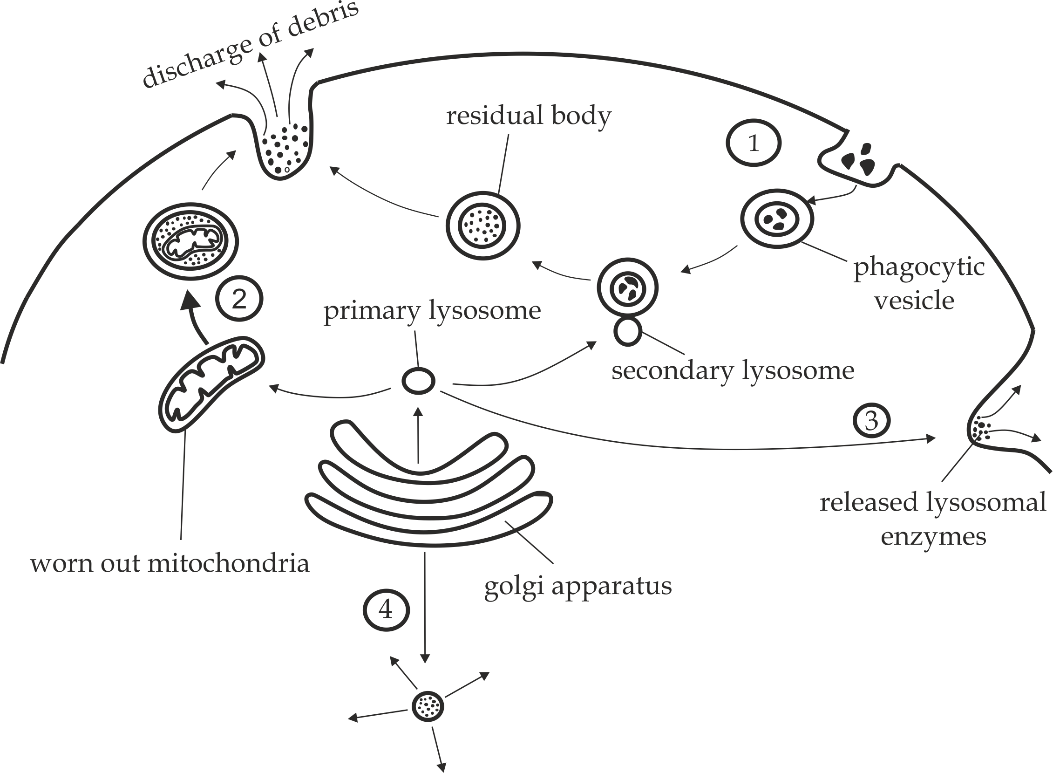

**Functions of lysosomes;** 1 – phagocytosis; 2 – Autophagy; 3 – exocytosis;

4 – Autolysis *(Fig 1.28)*

**Sample question – 40**

**Famous question**

**Style 1: Kilakala sec school terminal Exam 2010**

1. What are lysosomes?
2. Describe the structure of lysosomes.
3. With respective reasons, outline the parts of your body which are expected to have large number of lysosomes.
4. Briefly elaborate on the roles of lysosomes in living organisms.



**Bonus conceptual question**

**Kilimanjaro Mock 2020**

* Explain what will happen if the lysosomes are removed from the following cells or organelles:

1. Sperm cells
2. Uterus
3. Tad pole tail cells
4. White blood cells
5. Secondary oocyte

**Hints:**

Oppose the biological significance of each cell or organelle above.





**Style 2: Necta question**

* Study the **figure 2** below and answer the questions that follow.

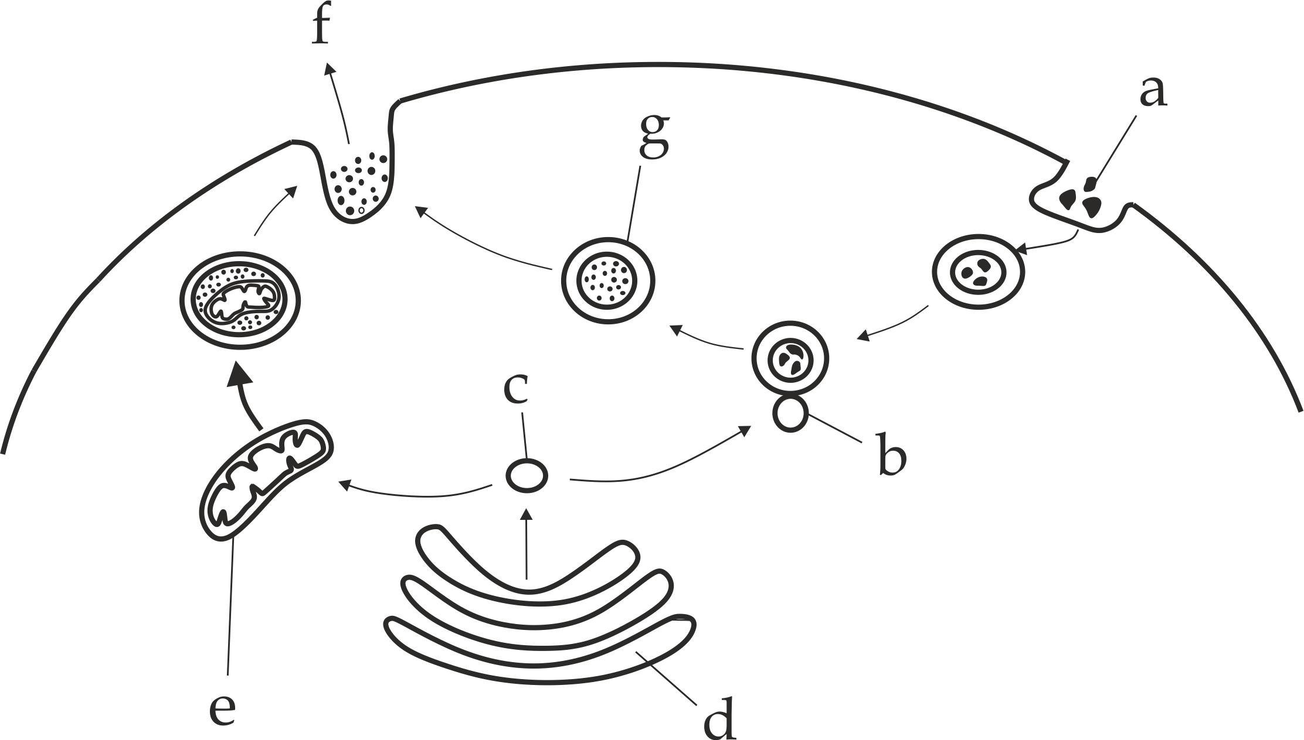

**Figure 2**

1. Explain what is taking place in figure 2 above in the processes labelled **a** and **f**.
2. Identify the structure labelled b, c, d, e and g.
3. What role will structure c play when cell dies?
4. **MICROBODIES**

**Microbodies** are small, spherical organelles bounded by a single membrane which contains powerful oxidative enzymes such as **catalase.** Microbodies are also known as **peroxisomes,** because they breakdown hydrogen peroxide (H202) into waterand oxygen gas.

Peroxisome

H2O2 H2O + O2

**Structure of Microbodies**

Structurally, Microbodies are small spherical vesicles, **0.2 – 0.5µm** in diameter. The microbodies are bounded by a single membrane, the inner contents of microbodies are finely granular, but sometimes a crystalline core is visible by electron microscope in the centre of the microbodies. This crystalline core is a crystalline protein, called **catalase enzyme** as shown in*Figure 1.29*.

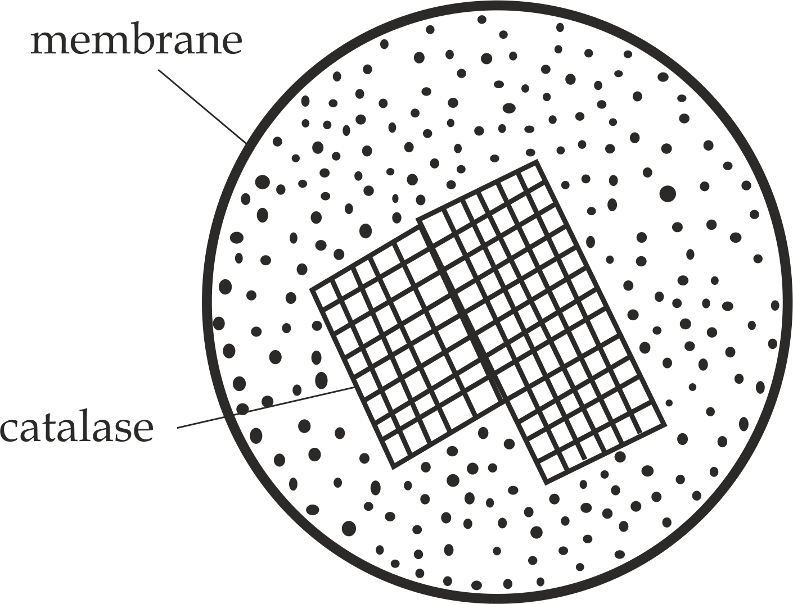

***Fig 1.29*** *Structure of peroxisome*

**Occurrence**

In animals, **Microbodies** are mostly found in the liver and kidney cells, while in plants, they are found mostly in plant cells where photorespiration occurs.

**Functions of Peroxisomes**

**Microbodies** play the following functions in a living organism;

1. **Peroxisomes** found in plant and animal cells are involved in the breakdown of poisonous hydrogen peroxide to water and oxygen in the presence of peroxidase enzyme.
2. In plants, there are special microbodies called **glyoxysomes** is abundant in lipid rich seeds, such as peanuts and castor oil. Its enzymes help to convert stored fats and oils to sugars necessary for rapid and early growth of the plants during seed germination.

Glyoxysome**s**

Fats sugars

1. In plants mesophyll cells, the peroxisomes contain glycolic acid oxidase that oxidizes glycolic acid to glyoxylic acid, by the process called **photorespiration.**
2. Microbodies also help to degrade the fatty acids and amino acids by a process called β – oxidation in the liver.



***Did you know?***

***“If you drink alcohol, nearly half of it is degraded in peroxisomes of your liver and kidney cells “.***

**What are the similarities between the microbodies and lysosomes?**

Microbodies and lysosomes usually share some features in common, these includes:

1. They are both spherical in shape.
2. They are both bounded by a single membrane.
3. They have hydrolytic enzymes.

**What are the main differences between microbodies and lysosomes?**

1. **Microbodies** contain digestiveenzymes while **lysosomes** contain catalaseenzymes.
2. **Microbodies** are derived from the ER while **lysosomes** are derived from the Golgi apparatus.
3. **Microbodies’** breakdown hydrogen peroxide into water and oxygen while **lysosomes** involve in endocytosis, exocytosis, autophagy and autolysis.

**Sample question – 41**

**Tahossa Ilala region 2020**

* Enumerate four (4) functions of microbodies.



1. **CELL VACUOLES**

**Cell vacuoles** are fluid - filled or solid filled membrane bounded spaces within the cytoplasm of a cell.

**Structure of cell vacuoles**

**In animals,** the vacuoles are small – sized, many and temporary, are often called vesicles and usually contain engulfed solids such as food or liquid such as water as shown in *Figure1.30 (a)*.

**In plants,** the vacuoles are large, distinct and permanent. In mature plant cell vacuoles occupies almost entire volume of the cell **(i.e. 90%).** Because of the central position of a vacuole, the nucleus and other cell organelles in plant cells are pushed to the periphery or near the cell membrane. The vacuole is bounded by the membrane, called **tonoplast**. The vacuole is also filled with **cell sap** which is a watery solution rich in sugars, amino acids, proteins, minerals, metabolic wastes such as alkaloids and pigments such as anthocyanin as shown in *Figure 1.30 (b).*

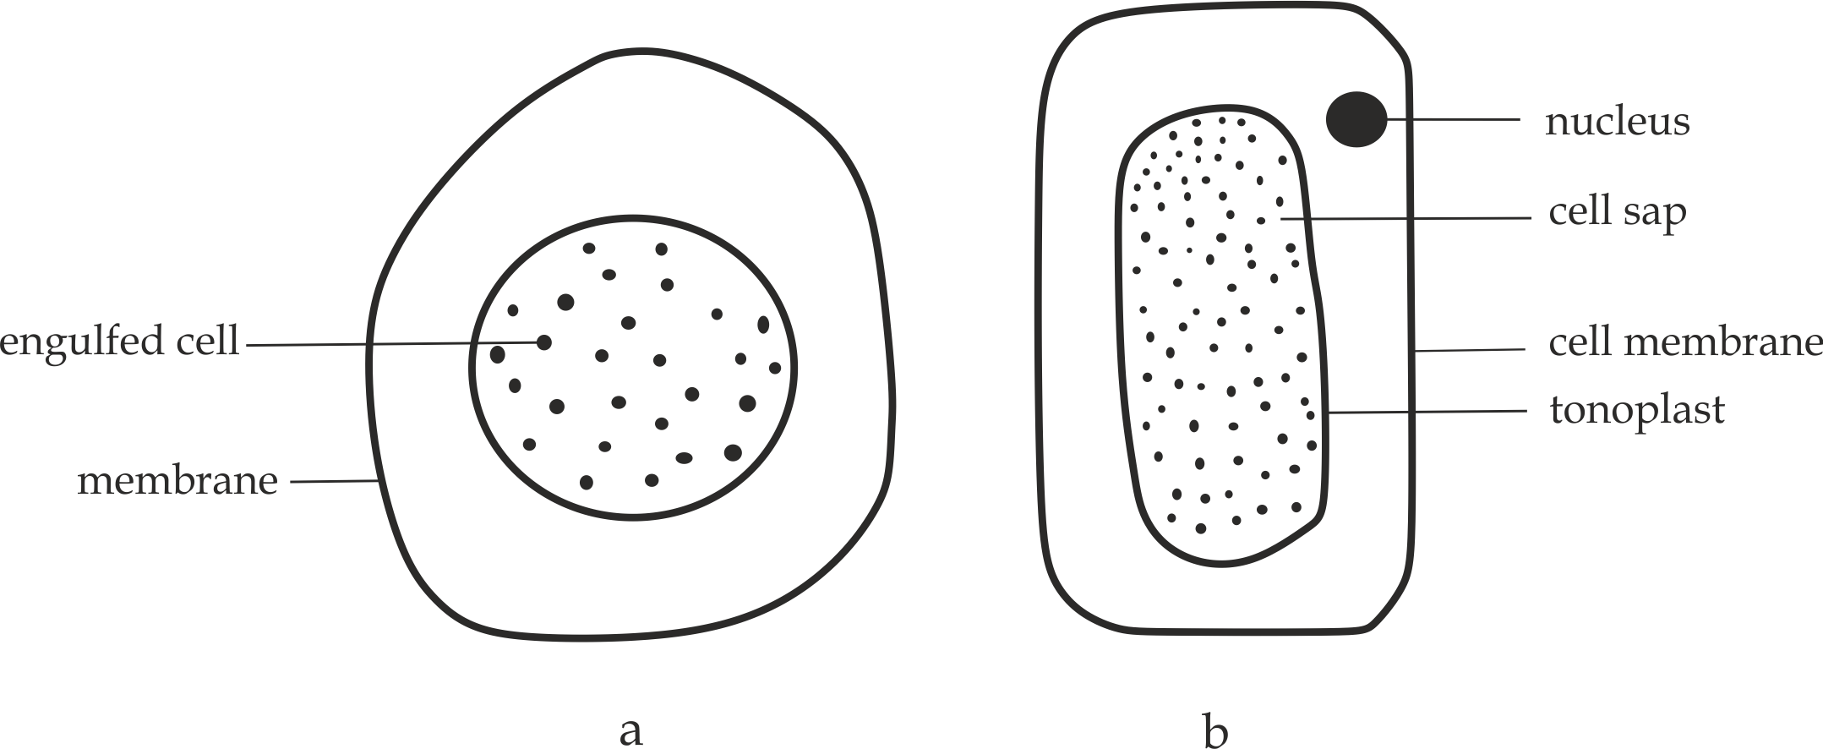

*Fig1.30 (a) Animal cell vacuole, (b) plant cell vacuole*

**Functions of cell vacuoles**

Cell vacuoles in plants play the following functions:

1. They act as temporary storage for **food,** such as amino acids and sugars.
2. They act as temporary storage for **metabolic wastes** products prior to elimination such as alkaloids.
3. They contain hydrolytic enzymes and so perform function similar to those of **lysosomes** in animal cells. This process occurs when the tonoplast rupture and releases its cytoplasm contents (enzymes) into the cytoplasm which digest the entire cell.
4. The contain **anthocyanin’s** which provide colour to flowers, fruits and buds. These pigments facilitate pollination and seed dispersal.
5. They maintain turgor pressure in plants by turgidity.



**Sample question – 42**

**Necta question**

* What roles are played by the following organelles:

1. Lysosomes
2. Vacuoles
3. **CENTRIOLES**

**Centrioles** are hollow and cylindrical structures whose walls consist of parallel groups of microtubules arranged in a ring 3 – microtubules each. They are known as **microtubules organizing centre** as shown in *Figure 1.31***.**

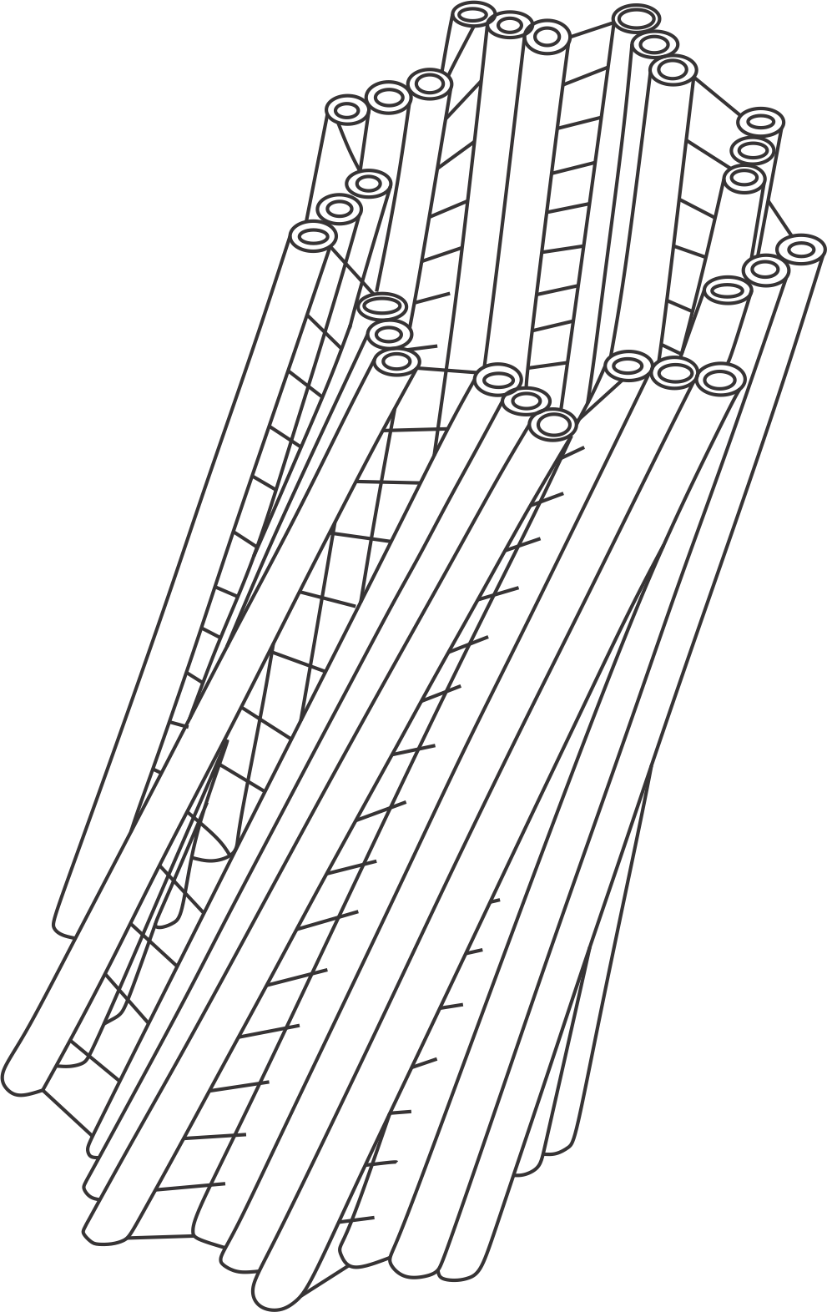

***Fig 1.31*** *one of the centriole present outside the nucleus of animal cells*

**Occurrence**

They are found in animal cells only in a distinct region known as **centrosome**. Despite of the absence of centrioles in plants, Plants cells contain **polar caps** which perform the function of centrioles.

**Functions of centrioles**

1. They help in **cell division** in animal cells. During cell division centrioles migrate to the poles of animal cells and are involved in the formation of spindle fibres.
2. They give rise to **cilia** and**flagella** which aid in movement.

**Sample question – 43**

**Mbeya Mock – 53**

* Describe the structure, location and functions of centrioles in animal cells.



1. **RIBOSOMES**

**Ribosomes** are small and spherical cytoplasmic granules found in all cells.

They are called ribosomes because they are normally rich in **ribonucleic acid** **(RNA).**

**Types of ribosomes**

Basing on their size and sedimentation coefficient, there are **two (2)** types of ribosomes: 70’s ribosomes and 80’s ribosomes.

1. **70’s ribosomes**

70’s ribosomes are small ribosomes with a sedimentation coefficient of 70 Svedberg units (thus 70’s).

**Nature of 70’s ribosomes:**

70s ribosomes have the following general properties:

1. 70’s ribosomes occur in prokaryotic cells, but they are also found in the mitochondria and chloroplast.
2. 70’s ribosomes are smaller in size.
3. 70’s ribosomes are relatively lighter.
4. 70’s ribosomesconsist of two subunits, the large subunits, 50’s and the small subunits, 30’s.
5. **80’s ribosomes**

80’s ribosomes are ribosomes with a sedimentation coefficient of 80 Svedberg units (thus 80’s).

**Nature of 80’s ribosomes:**

80s ribosomes have the following general properties:

1. 80’s ribosomes occur in eukaryotic cells only.
2. 80’s ribosomes are larger in size.
3. 80’s ribosomes are relatively heavier.
4. 80’s ribosomes consist of two subunits, the large subunit, 60’s and the smaller subunit, 40’s.

**Occurrence**

They occur in both, prokaryotic and eukaryotic cells. In prokaryotic cells, they are found freely in the cytoplasm, whereas in the eukaryotic cells there are either attached to the outside of the endoplasmic reticulum or occur freely in the cytoplasm.

**Structure of ribosomes**

Structurally, ribosomes are small cytoplasmic granules **20nm** in diameter, each ribosome is made up of two subunits, a small subunit and large subunit – each of which contains half ribosomal RNA and half protein as shown in *Figure 1.32*.

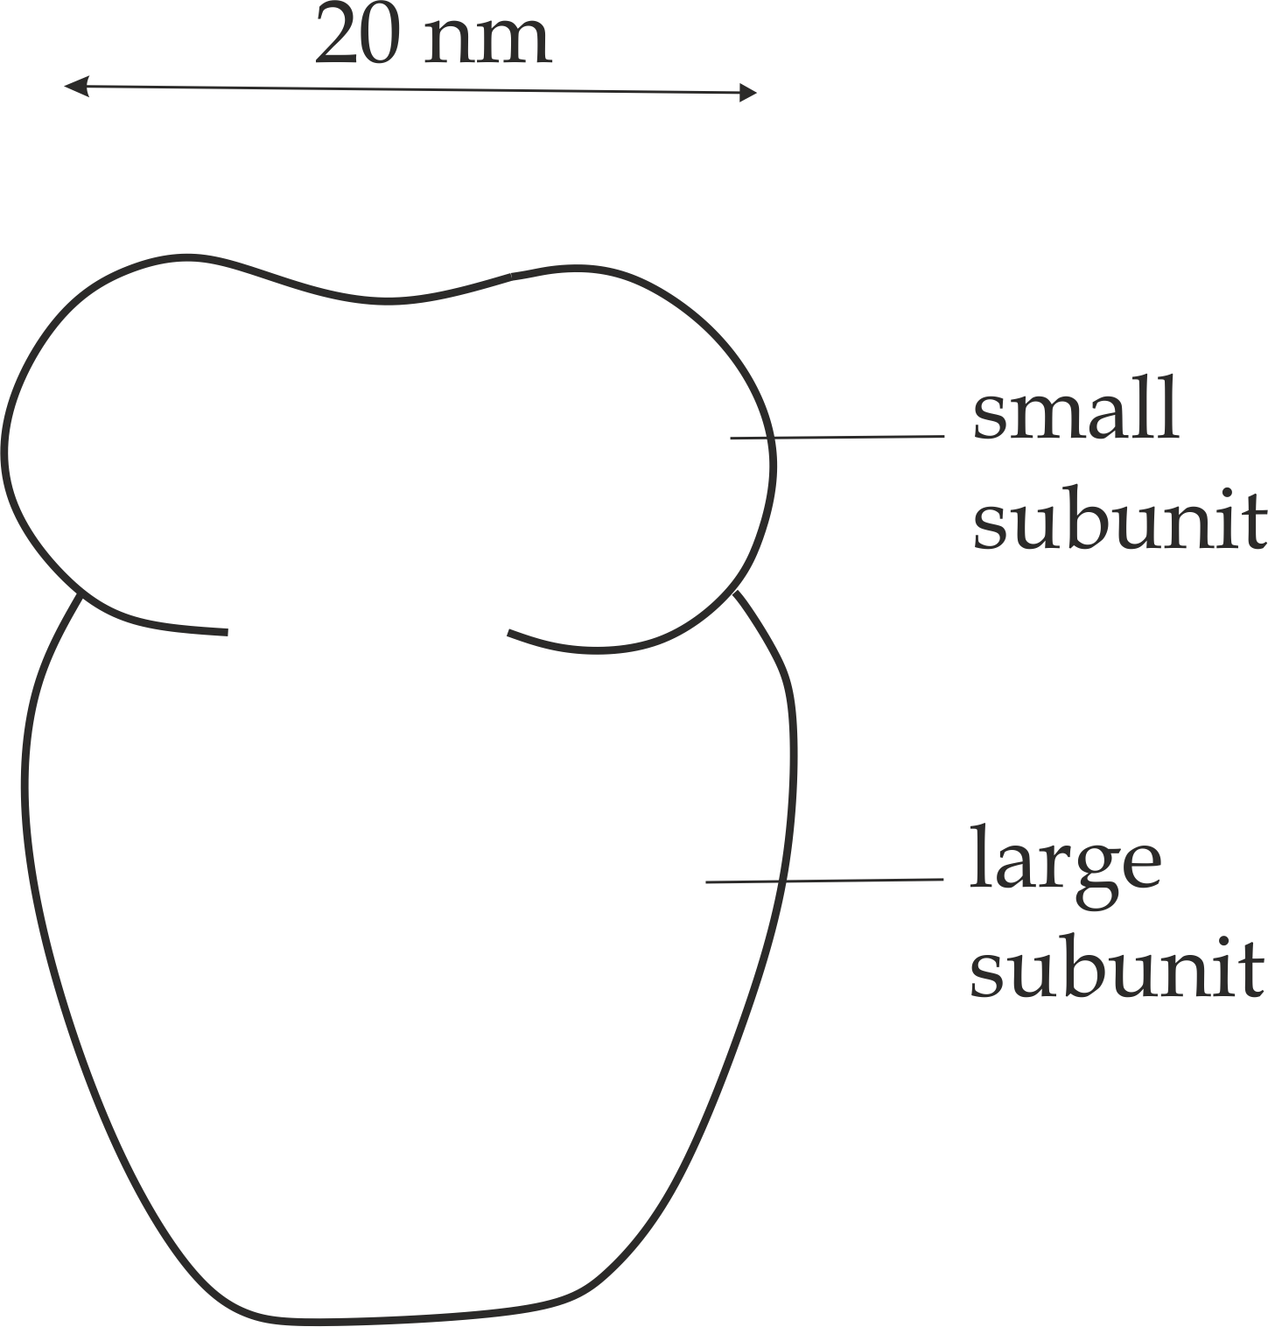

***Fig 1.32*** *Structure of ribosome*

**Function of the ribosomes**

1. Ribosomes are sites of protein synthesis; they provide surface area for polypeptide chain synthesis hence they are known as **protein factories.**



**Sample question – 44**

**Possible at any time**

1. Why ribosomes are known as protein factories?
2. Outline the differences between 70’s ribosomes and 80’s ribosomes.
3. **CELL INCLUSIONS**

**Cell inclusions** are storage food granules, they are also known as **Epigastric bodies,** because they are non-living structures of the cytoplasm.

**Types of cell inclusions**

Basing on their location, there are **three (3)** types of cell inclusions, these are; glycogen granules, lipid droplets and starch grains.

1. **Glycogen granules**

These are carbohydrates storage in animals; they are stored as a solution in the cytoplasm of **animal muscles** and **liver.**

1. **Starch grains**

These are carbohydrates storage in plants; they are stored in the **stroma of the chloroplast.**

1. **Lipid droplets**

These are fats and oils storage in animals and plants, i.e. in animals; fats are stored as **adipose tissues** while in plants oils are stored in the **stroma of** **the chloroplast.**

**Function of cell inclusion**

1. They act as energy stores.



**Sample question – 44**

**Possible at any time**

* Write short notes on cell inclusion.

**1.5: MEMBRANE BOUNDED ORGANELLES**

These are internal membranes that surround the organelles in the eukaryotic cells. The internal bounded organelles are advantageous in eukaryotic cells due to the following reasons:

1. **The internal membrane – bounded organelles** limits and encloses the contents of the organelles such as tonoplast in the cell vacuole.
2. **The internal membrane bounded organelles** control the entry and exist of materials across the organelles such as nuclear envelope in the nucleus.
3. **The internal membrane bounded organelles** increase the surface area for metabolic reactions such as folded inner membrane of the mitochondria for electron transport chain.
4. **The internal membrane bounded organelles** increase surface area for attachment of enzymes such as in ribosomes.
5. **The internal membrane bounded organelles** allow division of labour, as many biological processes take place in different organelles within the same cell without interference, leads to specialization.
6. **The internal membrane bounded organelles** prevents autolysis of the cell, if the hydrolytic enzymes are left free in the cytoplasm may digest the host cell such as enzymes in the lysosome could affect the host cell if lysosome membrane was absent.

**Sample question – 45**

**Necta 2007/ Biology 1**

1. Give two functions of each of the following cellular organelles:
2. Nucleus
3. Endoplasmic reticulum
4. Golgi apparatus
5. Lysosome
6. What advantages does a eukaryotic cell gain by having internal membrane bounded organelles?



**Types of membrane bounded organelles:**

The following are the **five (5)** most common types of membrane bounded organelles**:**

1. **Cell membrane**
2. It encloses and protects the inner contents of the cells.
3. It controls the entry and exit of materials into and from the cell.
4. It acts as a receptor.
5. It acts as a recognition site.
6. It acts as enzyme.
7. It acts as a junction.
8. **Nuclear envelope**
9. It encloses and protects the inner contents of the nucleus.
10. It has nuclear pore which controls the entry and exit of materials into and from the nucleus.
11. It makers the endoplasmic reticulum which contains ribosomes for protein synthesis.
12. **Mitochondrion membrane**
13. It encloses and protects the inner contents of the mitochondria.
14. It controls the entry and exit of materials.
15. The inner membrane is folded into cristae which increase the surface area for metabolic reactions.
16. **Chloroplast membrane**
17. It encloses and protects the inner contents of the chloroplast.
18. It controls the entry and exit of materials.
19. **Tonoplast**
20. It encloses the inner contents of the cell vacuole.
21. It creates turgor pressure.



**Sample question – 46**

**Necta 1999/ Biology 1**

* Mention any **five (5)** types of membranes and state one function of each

**1.6: CELL DIFFERENTIATION**

**Cell differentiation** is the process of cell transformation from one form to another leading to development of specialized types of cells for carrying out specific function as shown in *Figure 1.33*. This process involves biochemical and structural changes. Cell differentiation leads to cell specialization which in turn leads to **division of labour**. Division of labour is whereby each cell does what it is the best suited to do, this lead to efficiency.

**General overview:**

**In unicellular organisms,** the single cell itself performs all essential life functions inside the boundaries of the cell such as feeding, movement and reproduction. Although they perform all functions adequately, they cannot be totally efficient at all of them, because each function requires different type of cellular structure. One activity may be best carried out by a long, thin cell, while another might suit a spherically shaped cell. No one cell can provide the best conditions for all functions. For this reason, the cells of **multicellular** **organisms** are each adapted in different ways to perform particular role. In other words, each cell becomes specialized in structure to suit the role that it will carry out; this is known as **cell differentiation.**

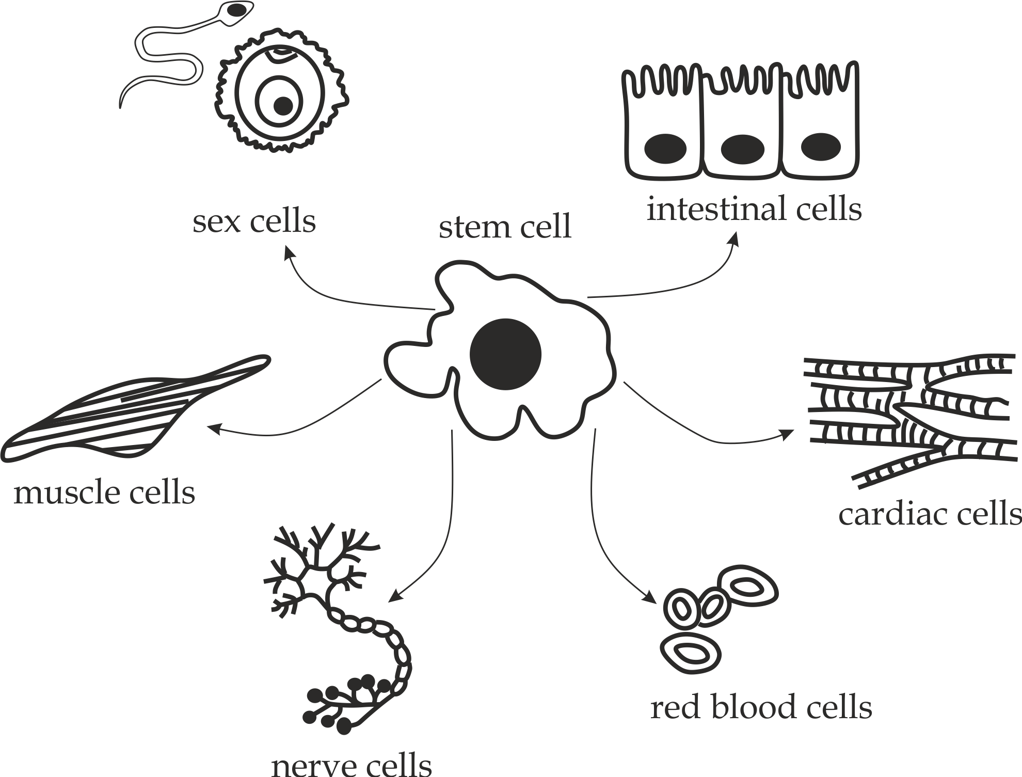

***Fig 1.33*** *Cell differentiation*

**Sample question – 47**

**Tai question**

1. Using vivid examples, explain the concept of cell differentiation.
2. Explain why cell differentiation generally referred to as a cell division of labour.



**Importance of cell differentiation**

The following are the importance of cell differentiation in living organisms:

1. It modifies cells to suit their functions more efficiency.

Examples of adaptive features include:

* **Sperm cells** are mostly packed with numerous mitochondria, acrosomal enzymes and flagella. All these features facilitate more efficient fertilization of egg cells.
* **Egg cells** have numerous microvilli for absorption of food from the follicular cells and also contain a large proportion of cytoplasm which contains food reserve for the developing of embryo.
* **Nerve cells** have specialized features like **node** **of Ranvier** and **myelin sheath** which for rapid conduction of nerve impulse.
* ***RBC’S*** have no nucleus at maturity and biconcave in shape to provide large surface area to volume ratio for transportation of oxygen and carbondioxide gas.
* **Xylem vessels** have empty lumen and lignified cell wall for efficient carriage of water and dissolved minerals.
* **Muscle cells** have actin and myosin proteins for contraction and relaxation of the muscles.
* Nephrons have glomerulus for **ultra – filtration.**

1. It enables *cellular organization*, as a way of forming different tissues and organs which lead to an organism.
2. It forms the basis for embryonic stem cell research to identify stem cells that requires transplanting of organs such as kidney.
3. It helps in the treatment of cancer patient whereby cytopathologist identify the grades through differentiated cell tumor.

**Sample question – 48**

**Morogoro mock 2020**

1. Define the term cell differentiation.
2. Using four examples, explain how cell differentiation modifies cell to suit their function more efficiently.
3. What is the significances of cell differentiation in the organism in which it occurs?

